Welcome to our **NOG** project!

Submitted by - Ofry Halely and Guy Gedalya

**Compiling and running the project**

To Compile and run the project, Open DOCKER DESKTOP.

After that, in the command line from the main folder of the project (NetflixOG_4), you should enter the command "docker-compose up --build -d"

(If you want to see server logs you can omit the -d)

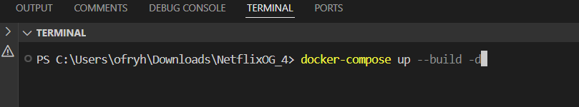

Once you press enter, the server will build. Once it's finished you should see something like this:

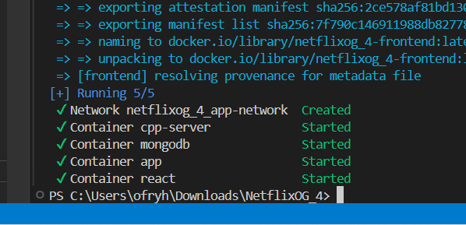

You can now access the website in your browser

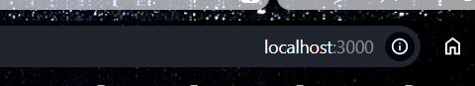

In the following pages we'll present how to use the website.

To run the Android app, open the NOG_Android folder in Android studio, it should recognize the build and let you run the app:



Connect your phone and click the play button. The App should download to your phone.

We explained how to use the app in the following pages (After the WEB).

**Presentation**

Throughout the course, we developed a movie streaming application step by step.

In the following pages, we will demonstrate how to use it.

**Let’s start with the web:**

On the next page, you can see the homepage – the first page displayed when entering the application.

The page includes basic elements such as a **Get Started** button for registration and a **Sign In** button for subscribers.

To enhance the user experience, we designed a logo based on the initials of our names combined with Netflix – **NOG** (Netflix, Ofri, and Guy) – along with a background inspired by Netflix’s design.

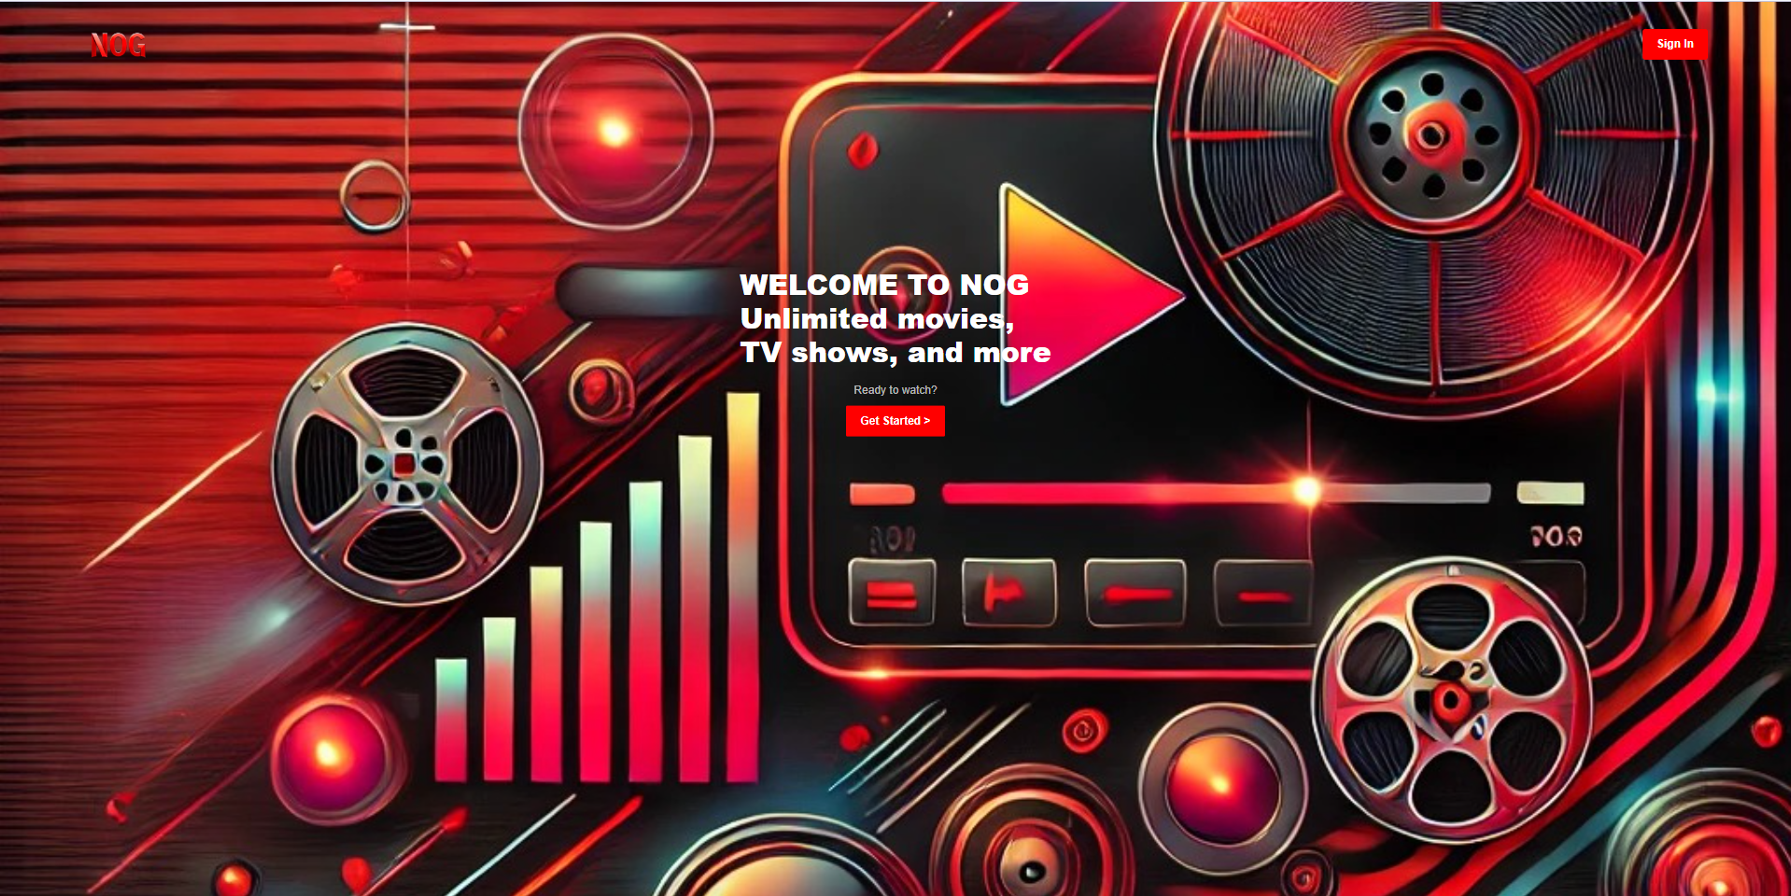

To start using the application, click on the **Get Started** button, and you will be redirected to the registration screen.

Please note that all details must be entered; otherwise, an error will occur.  
Additionally, the password must contain at least 8 characters, including at least one letter and one number.

The phone number must also follow the correct format.

After successfully registering and filling in all the required fields correctly, we will receive a confirmation message indicating that the registration was successful and the server processed the request!

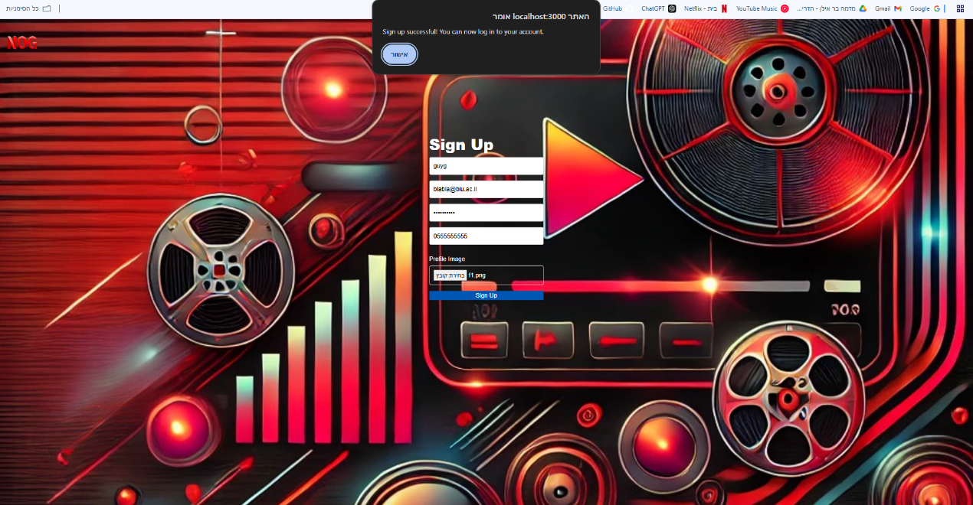

Now, we are automatically redirected to the login page, where we enter the credentials, we registered with and gain access to the main page.

Behind the scenes, the system generates a special token upon the request. This token allows the user to perform actions that are only accessible to logged-in users, such as accessing the homepage.

Without this special token, any attempt to access the homepage, even by manually entering the URL path, will result in an error and redirect the user back to the login page.

After entering the credentials, we will receive a message from the server confirming that the login was successful!

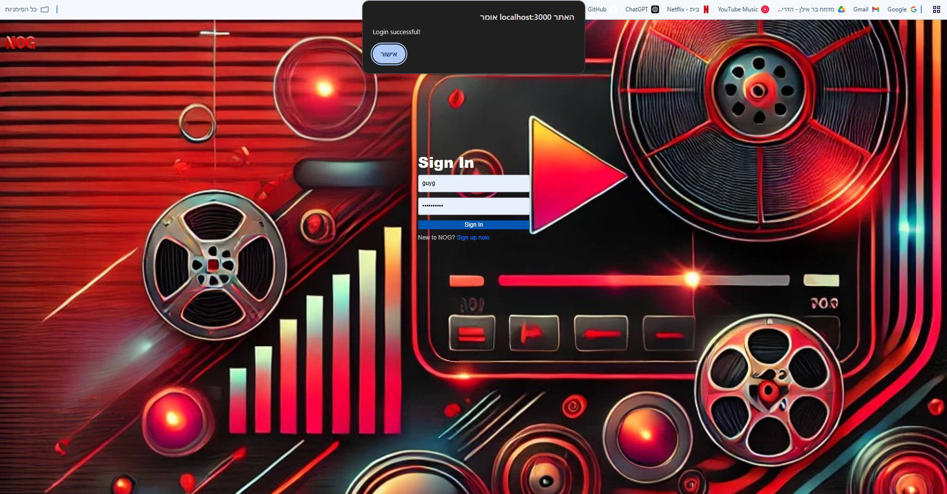

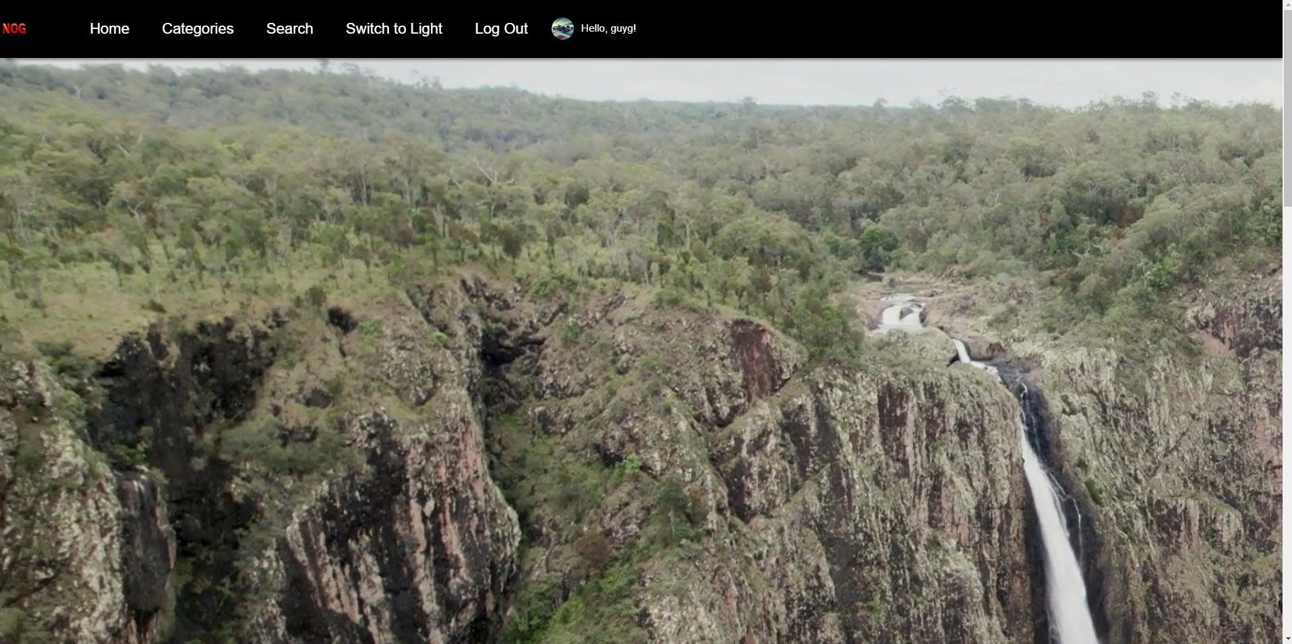

Now we are on the homepage – the homepage includes several functionalities:

1. A full-screen video player displaying a randomly selected movie from those categorized as **promoted**. We will notice that in each category, 20 movies are randomly selected.
2. A list of movies under categories that are also labeled as **promoted**.
3. A top navigation bar for seamless navigation across the application.

As you can see, the top navigation bar does not include a management option – this is because management access is granted only to users with database permissions.

To enable this option, we will access the database, locate our user, and assign them management permissions.

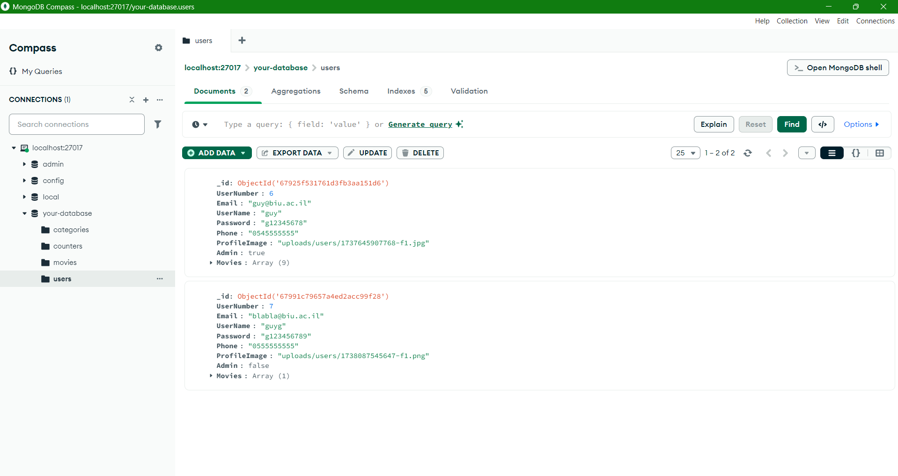

We can see that the user we created is the second user, and their Admin field is marked as "false".

We will update this field to "true" and expect to see the management toolbar appear.

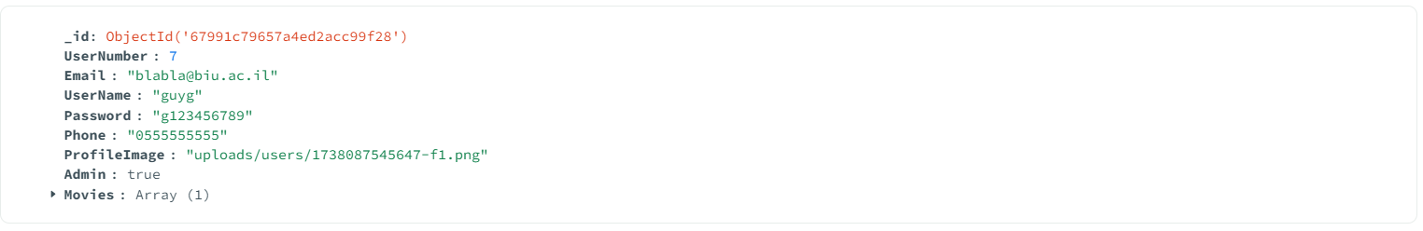

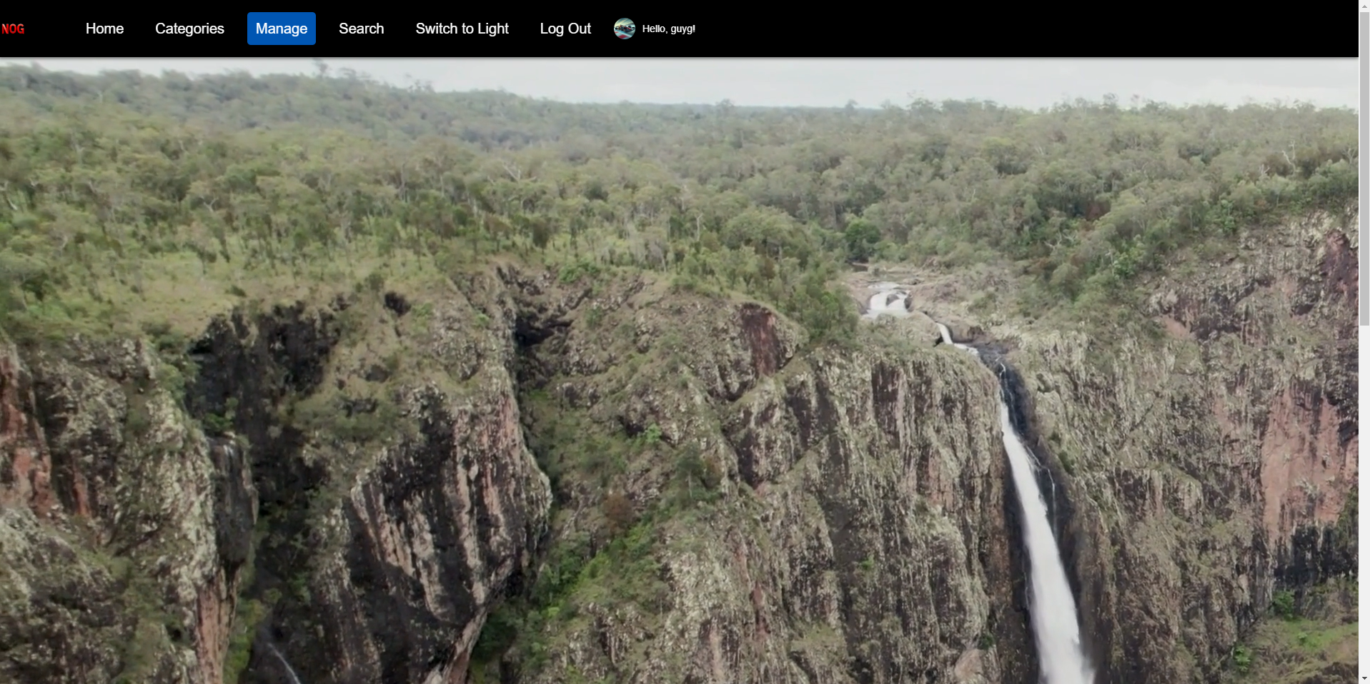

Now that we have seen that we have access to the management page, we will demonstrate how to add a movie.

First, we can see that there are two promoted movie categories: Action and Drama. The Action category contains six movies, while the Drama category has none. Now, we will demonstrate adding a movie to the Drama category.

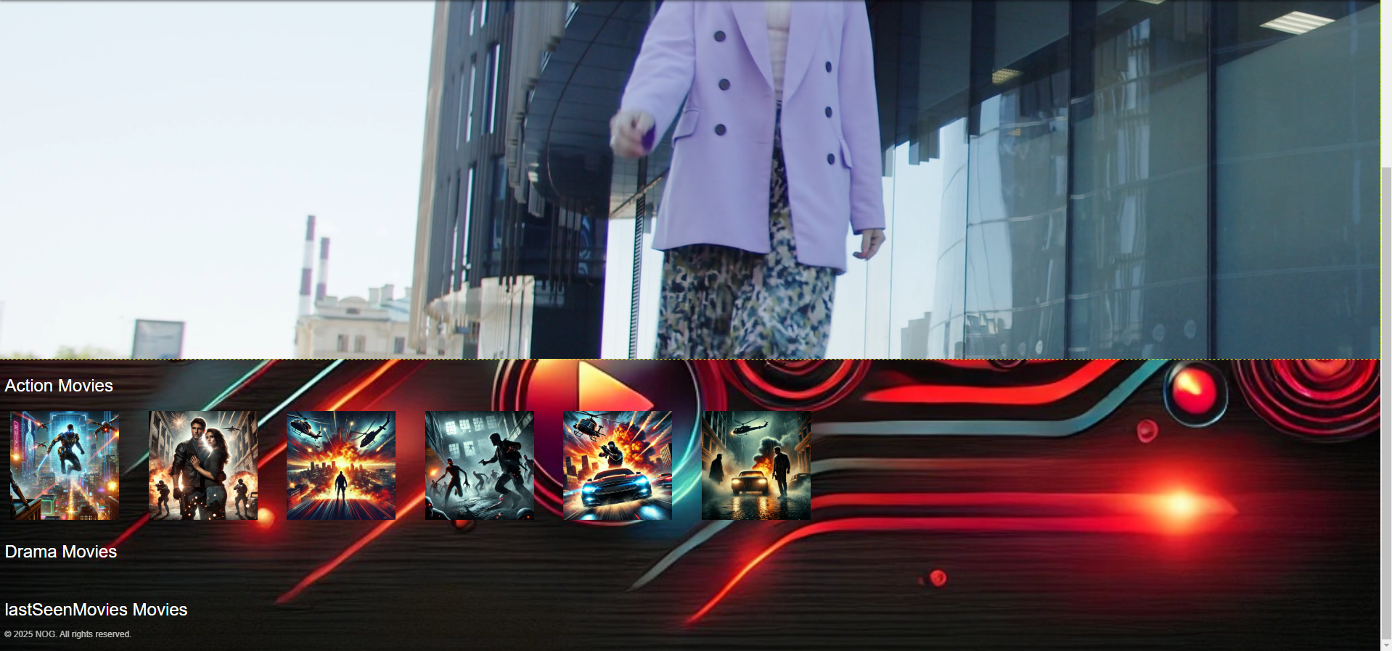

We will navigate to the management page and select the "Add Movie" option.

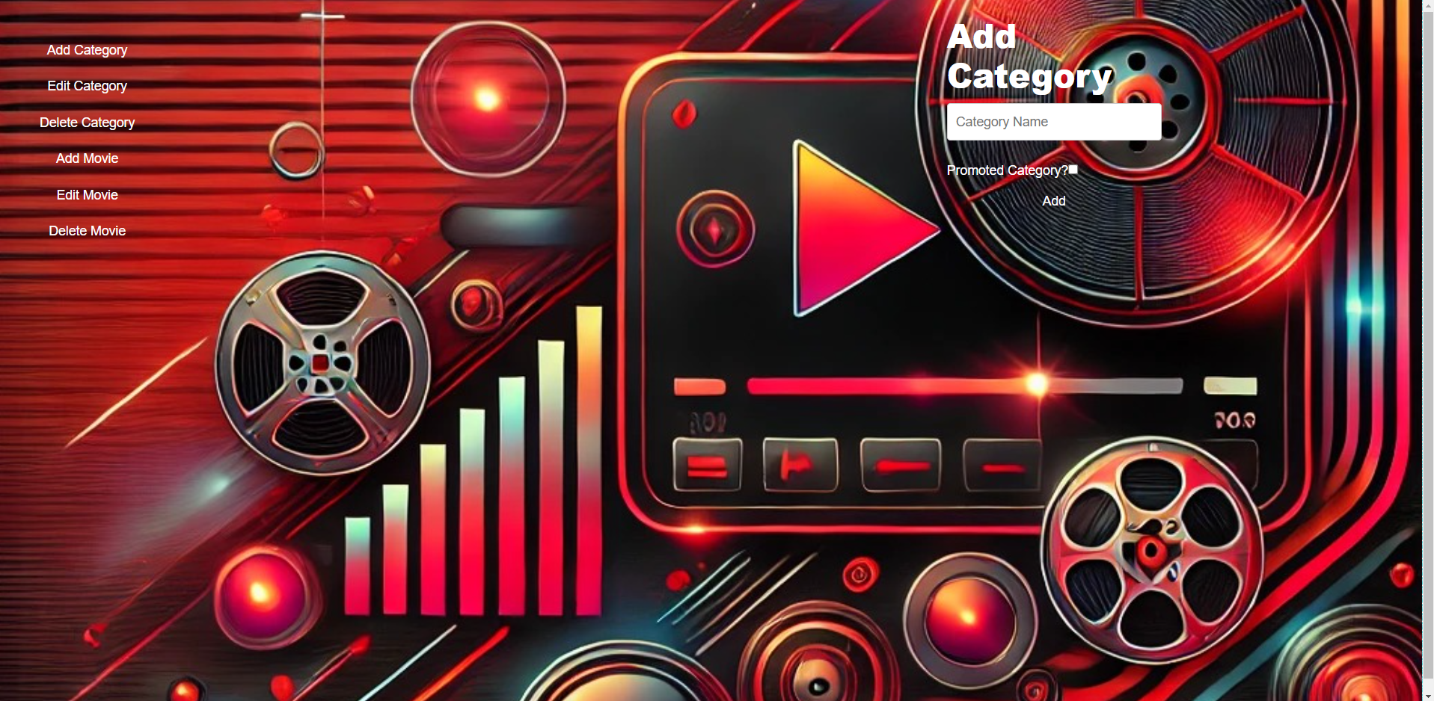

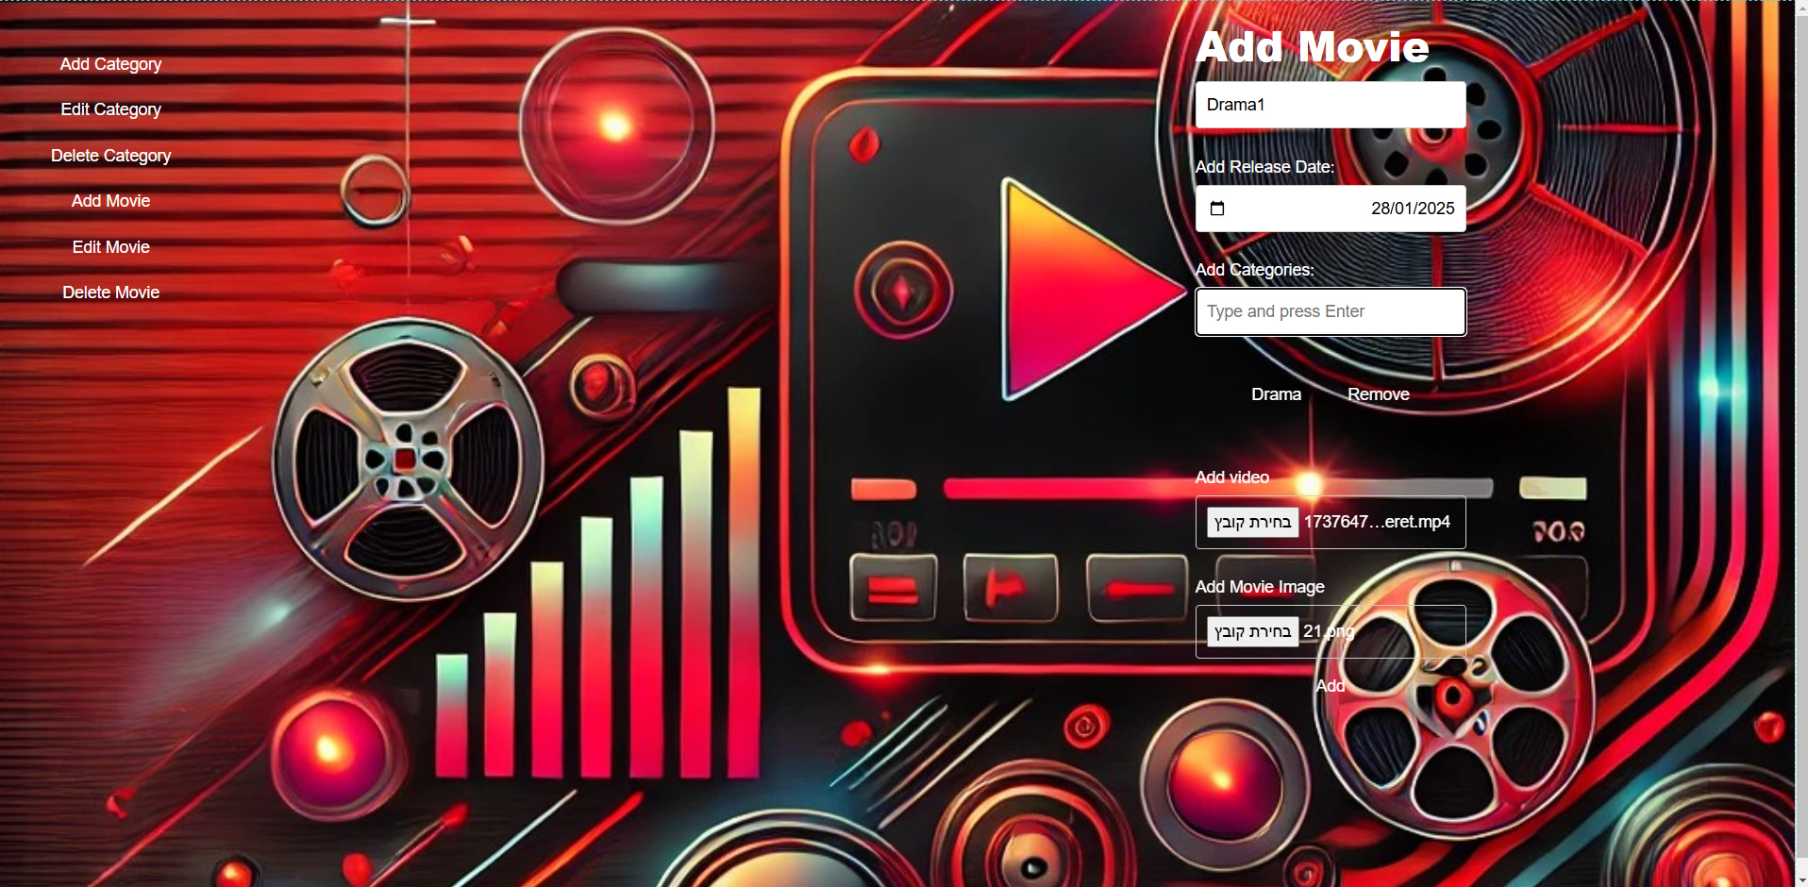

We will fill in all the required details, and then we will see our new movie listed under the "Drama" category.

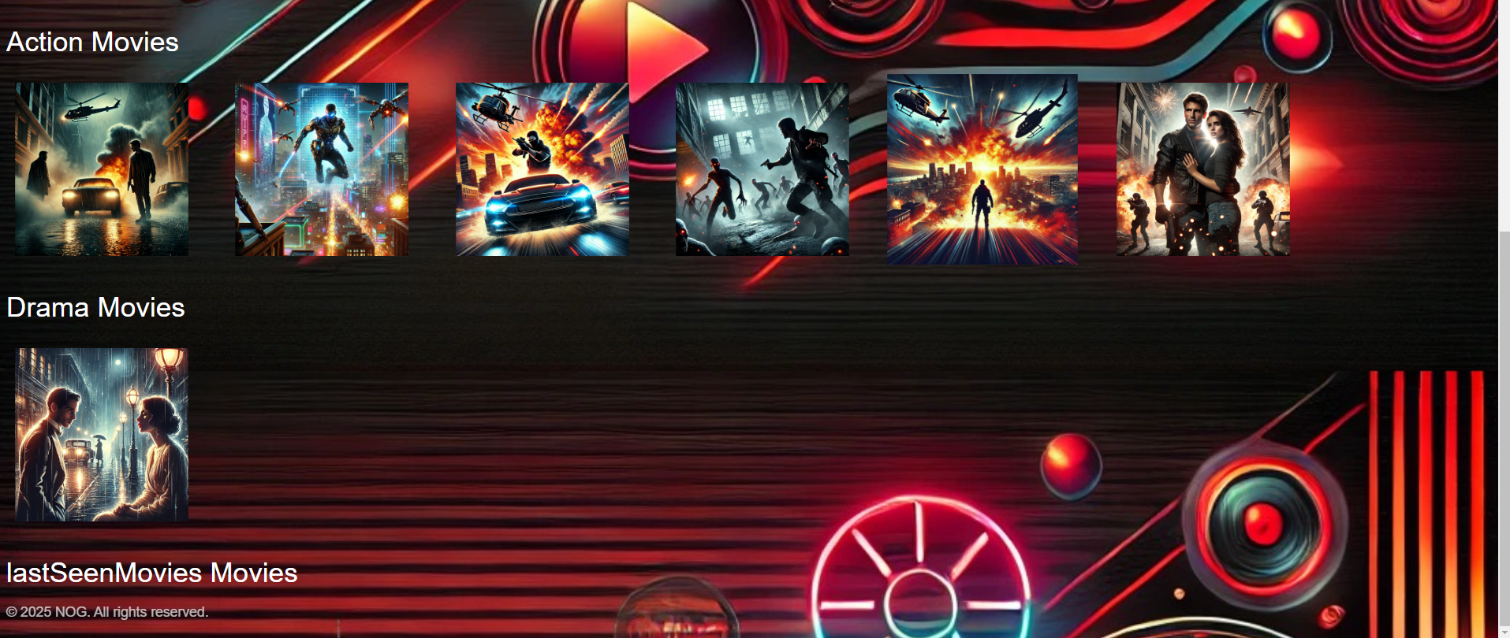

We will continue this process until we have all the drama movies we want.

Now we will demonstrate how to add two categories: one promoted and one not promoted.

We expect to see the promoted category appear on the homepage, while the non-promoted category will not. However, both categories will appear on the categories page.

The first category we want to add will be the **Science Fiction** category, and we will set it as a promoted category.



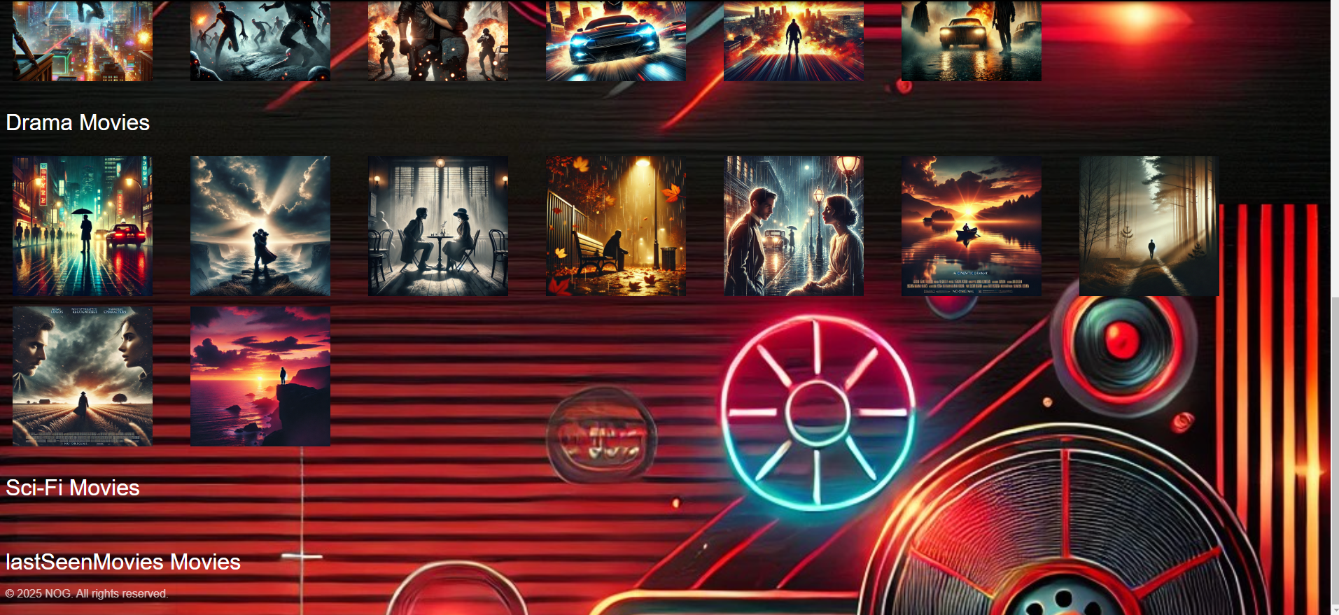

We can see that an empty **Sci-Fi** movie category has been created, and it appears on the homepage as expected. Now, we will add another category – **Romance** movies – and we will not promote it.



We will return to the homepage and observe that the **Romance** category is not displayed.

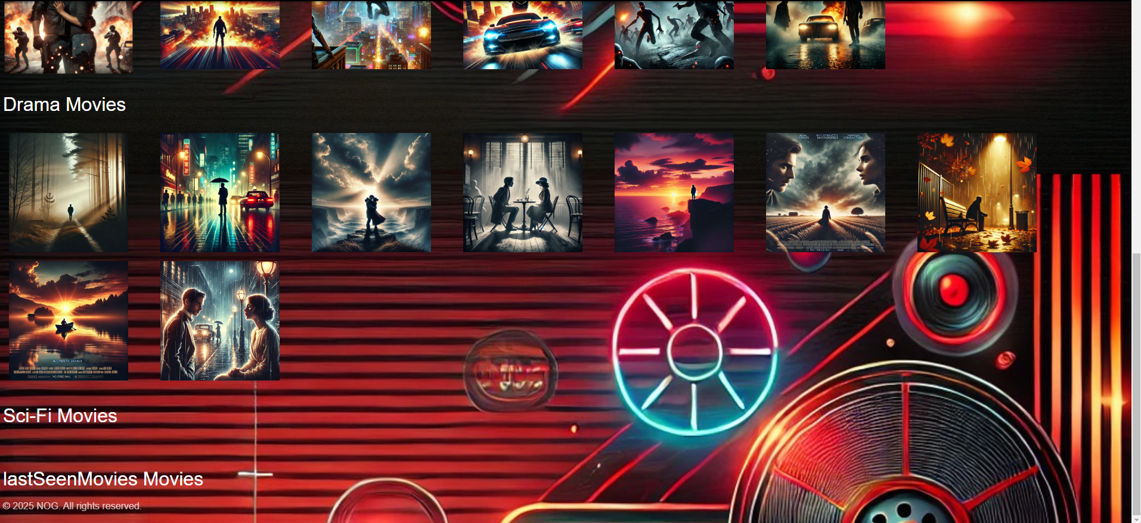

Now we will navigate to the categories page and see that both categories we added are displayed, as expected.

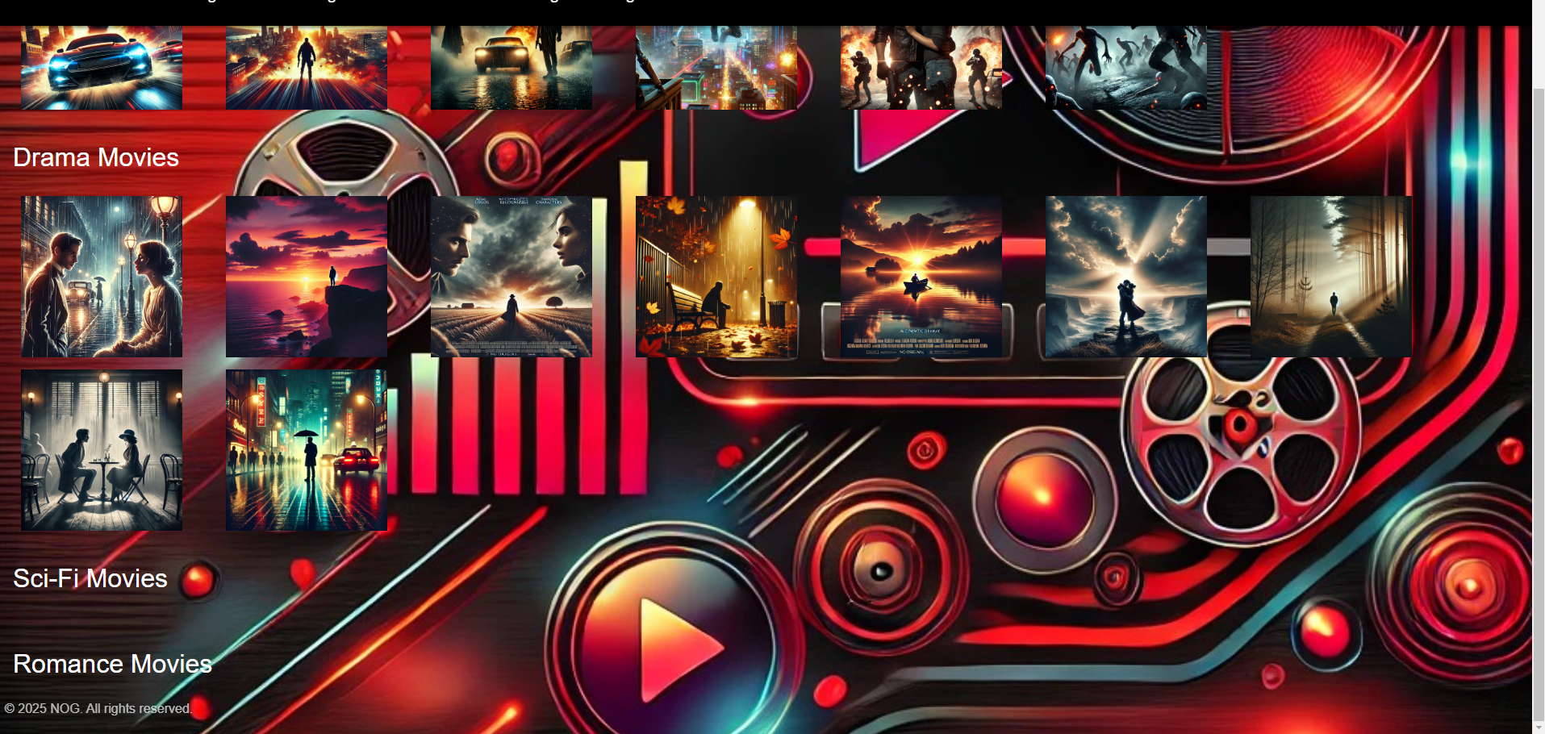

Now, we will add movies to both categories, following the same process demonstrated earlier.

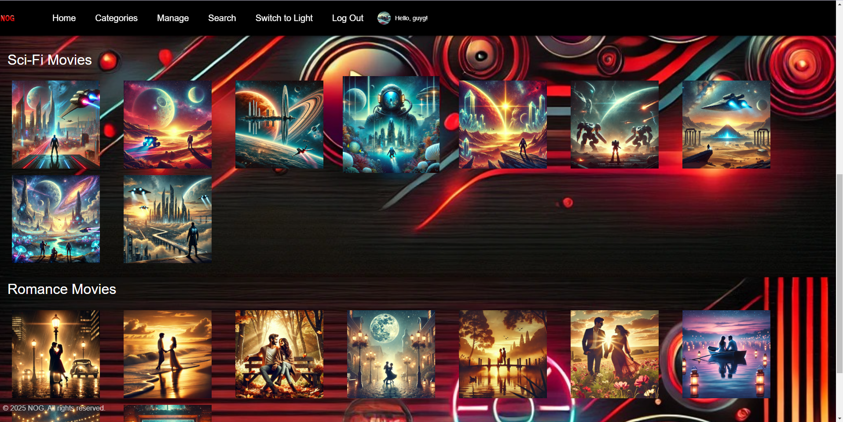

When we click on a specific image, a window will open displaying detailed information about the movie. For example:

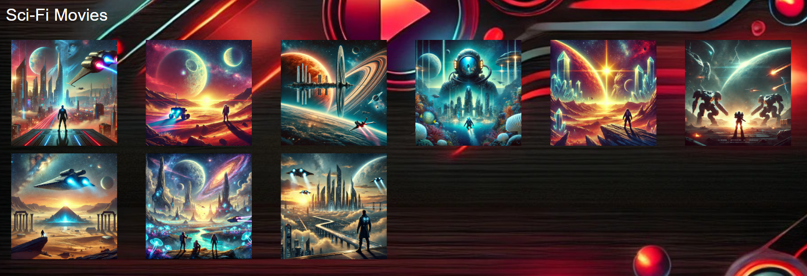

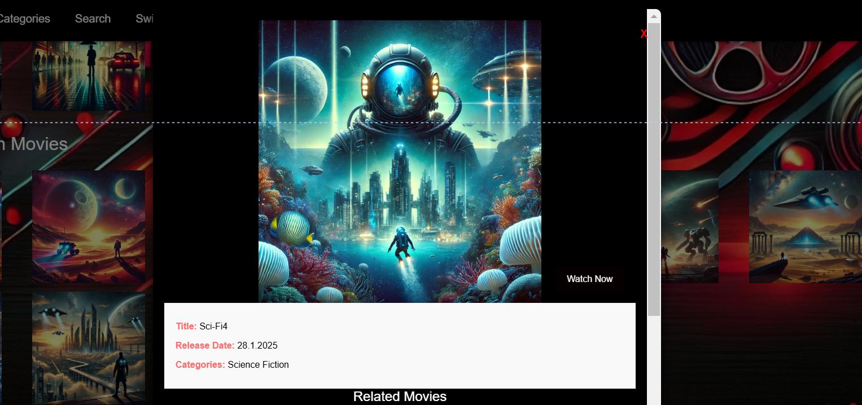

In addition to the image, we can see basic details about the movie, such as the title, release date, the category it belongs to, and other recommended movies based on this one. Also there is an exit button.

Additionally, there is a **Play** button that, when clicked, starts the movie and adds it to the "lastSeenMovies" list.

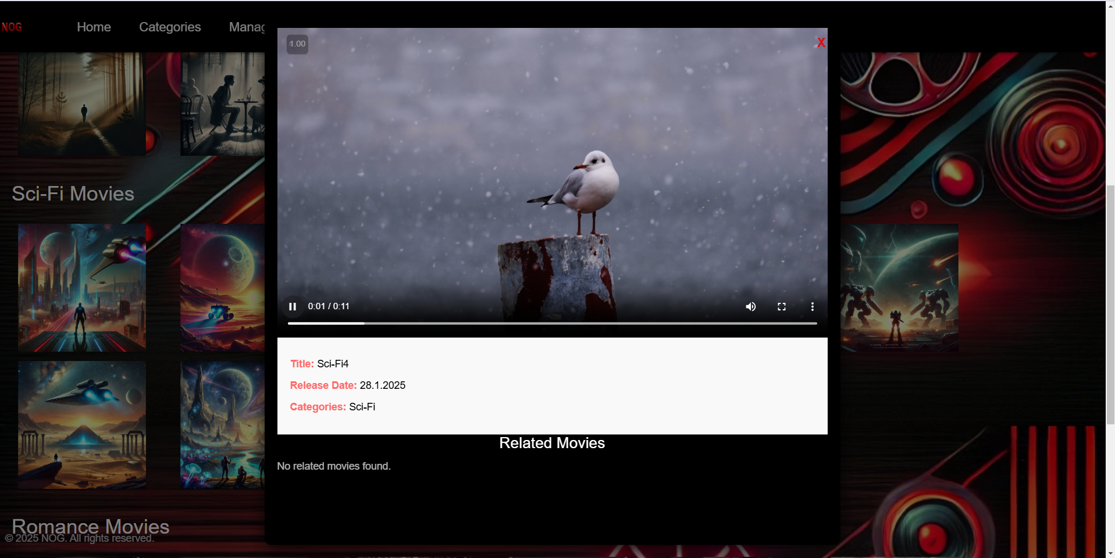

After clicking the **Play** button, the movie begins to play.

We have the option to control the movie's position, adjust the volume, pause or resume play, and toggle between Fullscreen and minimized modes.

Now, when we return to the homepage, we can see this movie no longer in its regular category but instead listed under the "lastSeenMovies" section.

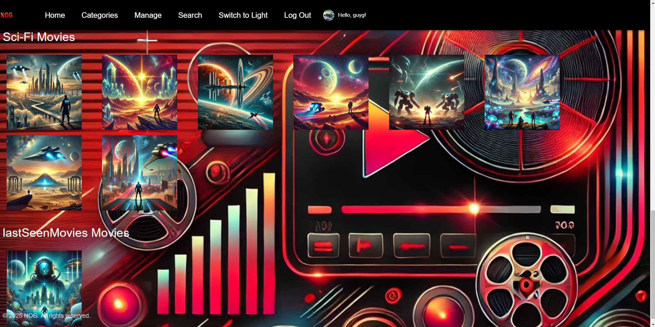

Now, we will demonstrate how to edit movies. We will select a specific movie that we want to edit. For example:

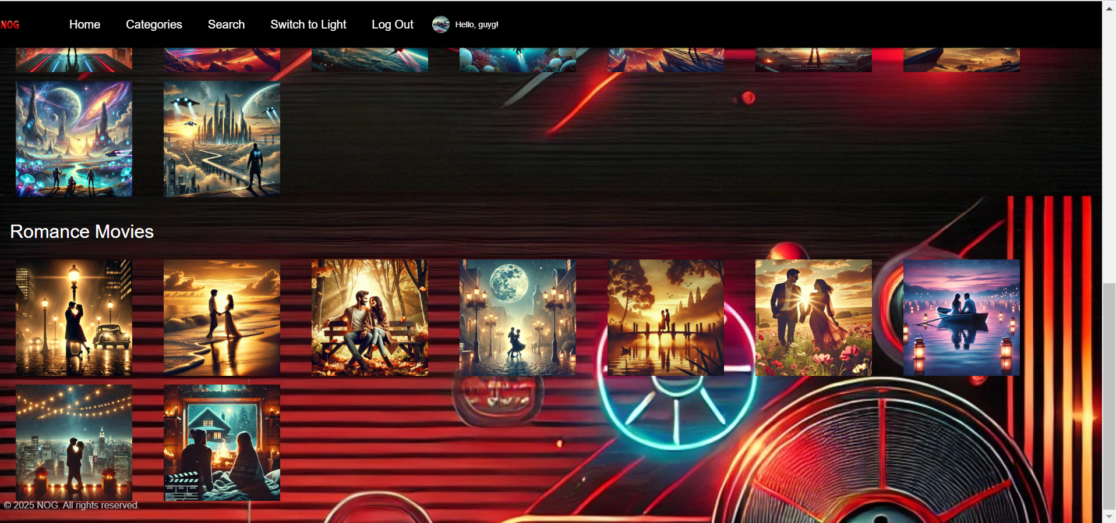

We will first review the movie's details before making any changes.

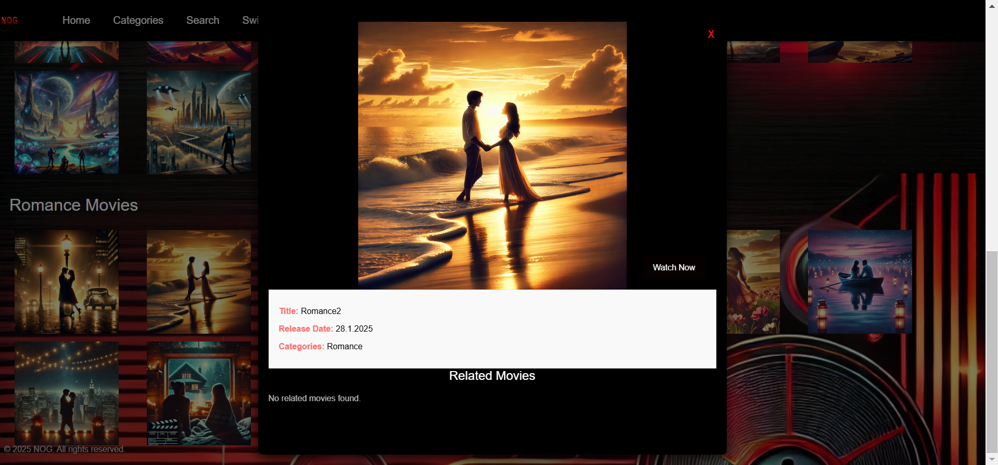

Next, we will go to our database, search for the movie, and locate its **ID**.

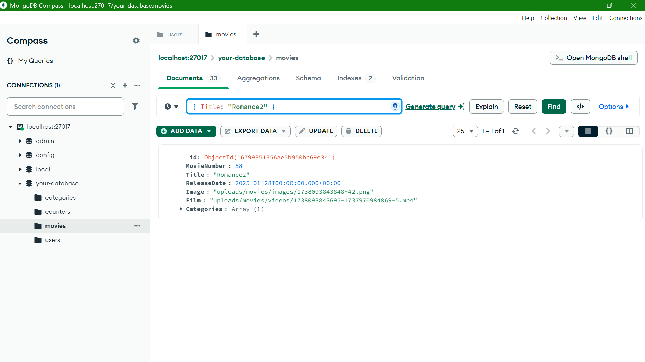

We will copy the **ID** and navigate to the management page.

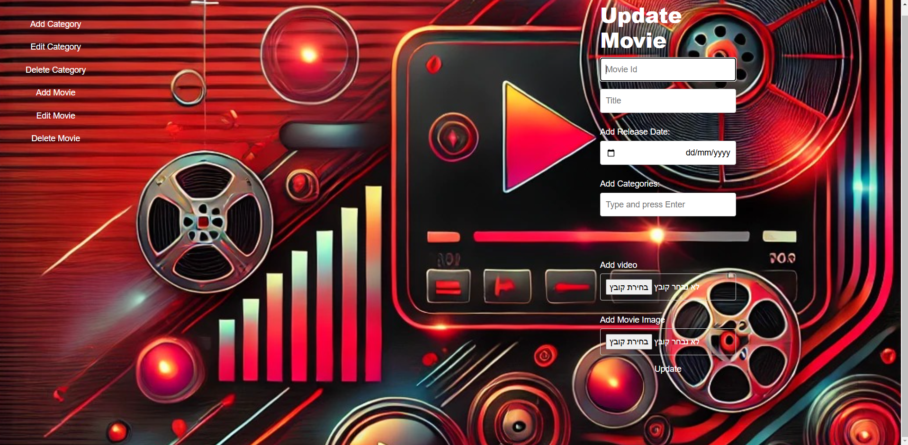

We will input the **ID** and fill in the fields with the desired updated details for the movie.

For example:

* Assign it a new name: **Romance2Update**
* Keep the same release date
* Add an additional category: **Action**
* Change the movie's image to a new one.

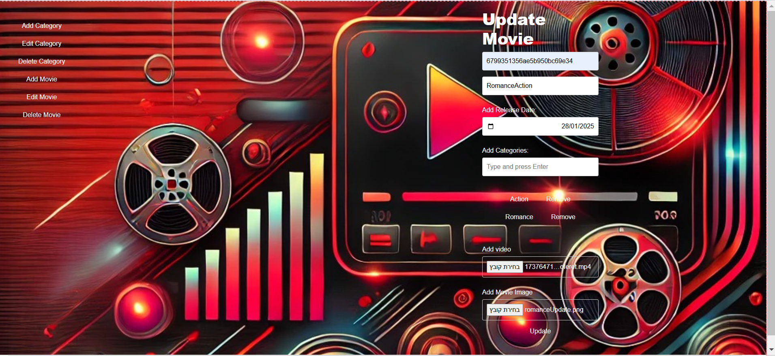

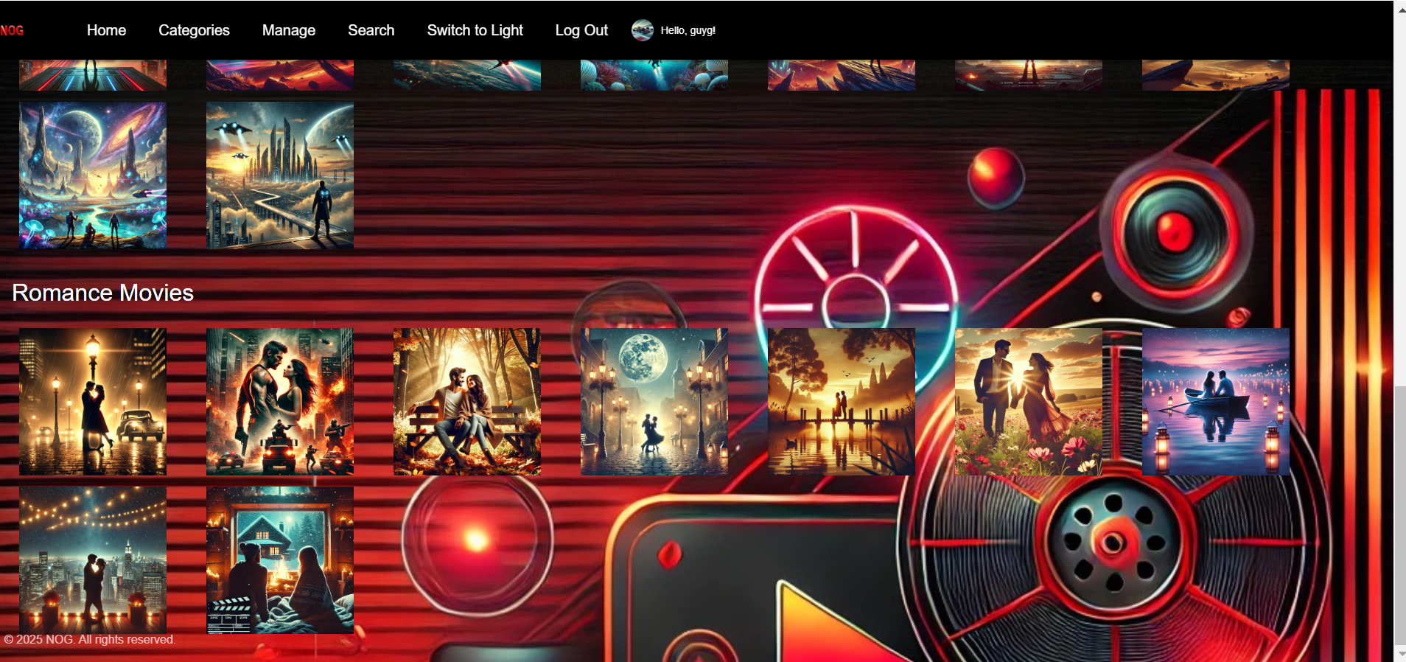

We can see that the previous movie image has been replaced with the new image of the updated movie.

We can also see that the movie now belongs to the **Action** category as well.

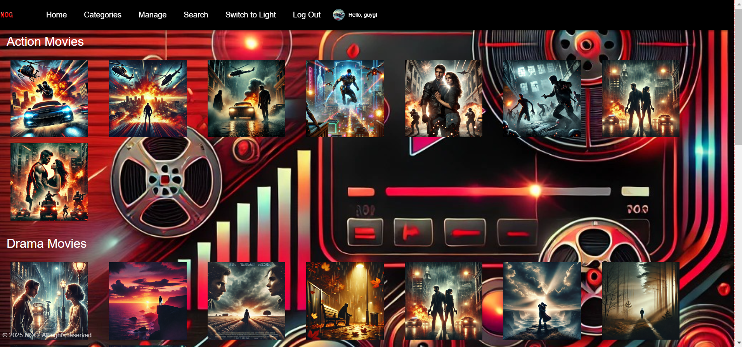

When we click on the movie image, we can see that its name, the categories it belongs to, and its representative image have all been updated.

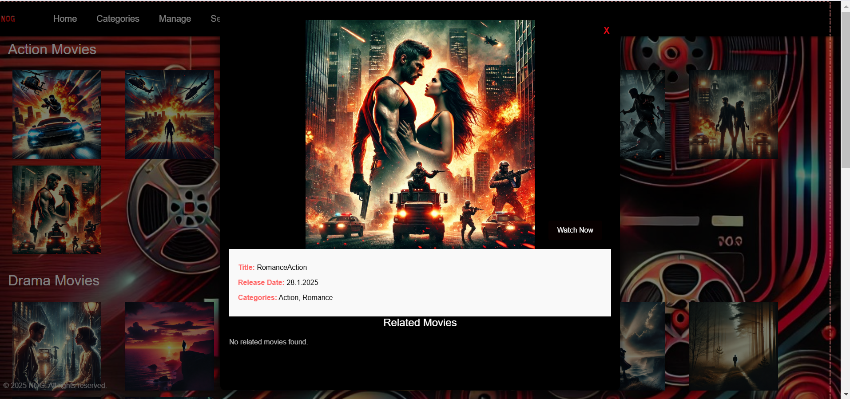

Now, we will demonstrate how to edit a category. Let's say we want to change the category name from **Sci-Fi** to **Science Fiction**.

First, we will go to the database, search for the category, and locate its **ID**.

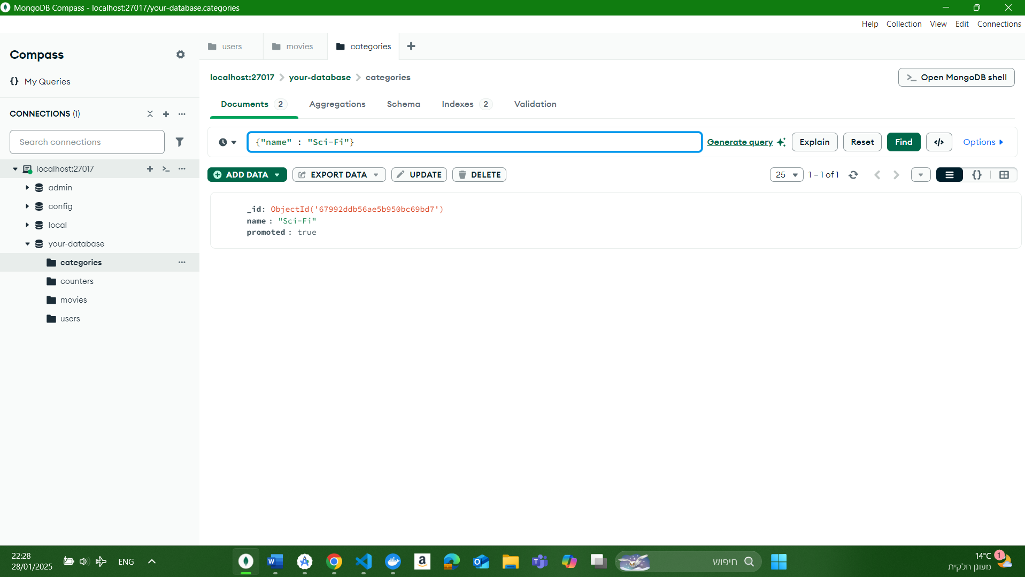

We will copy the **ID** of the category and then update the **name** field to **Science Fiction** and leave the category as **promoted**.

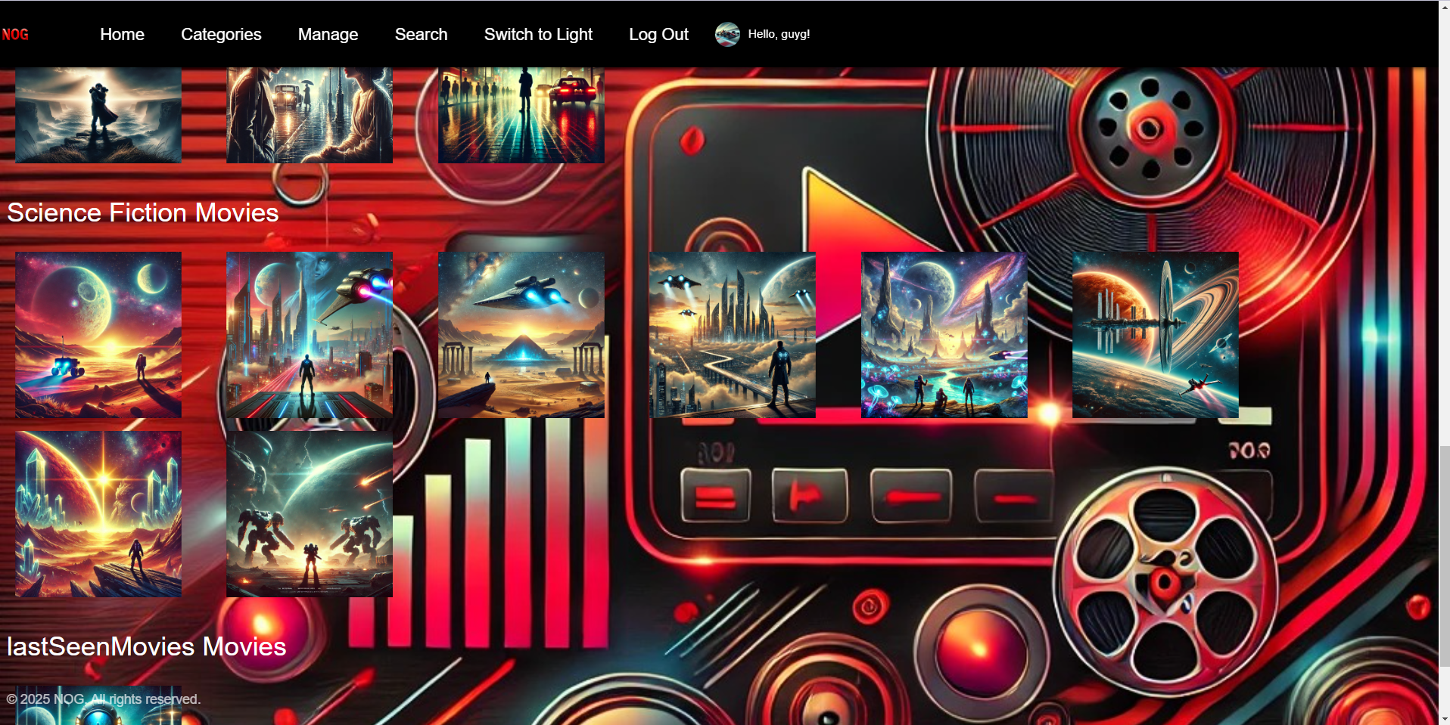

Now, we can see that the category remains promoted, it appears on the homepage, and its name has been updated to **Science Fiction**.



Now, let's demonstrate the search function. If we want to find all the movies containing the search term "Act", we will type **"Act"** in the search bar.

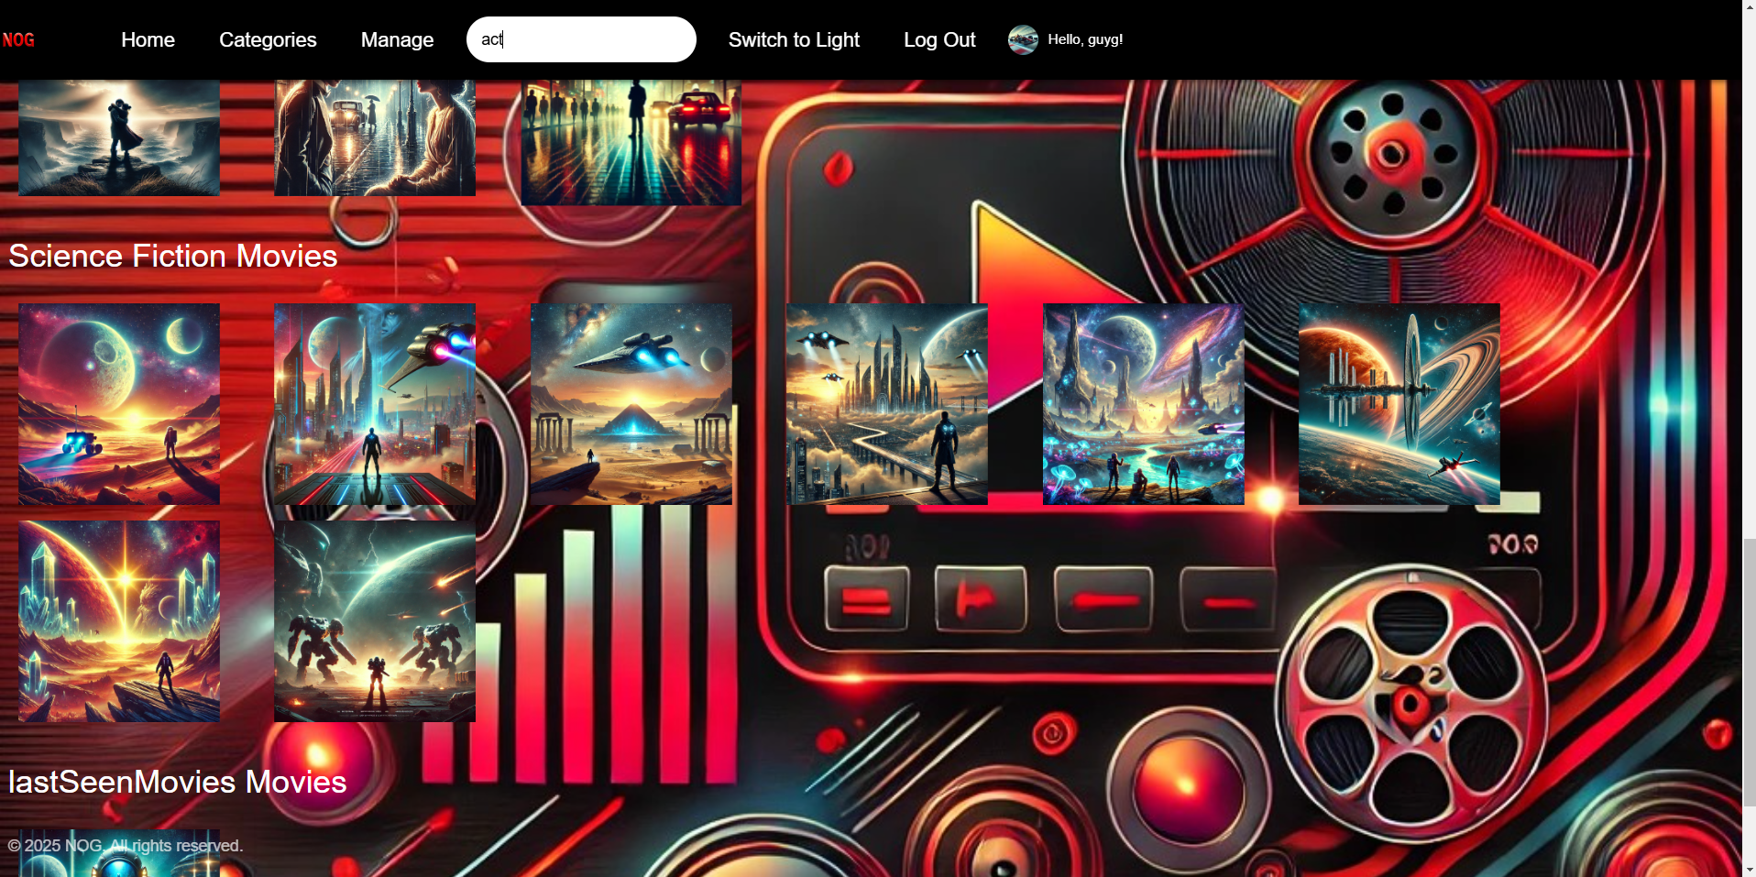

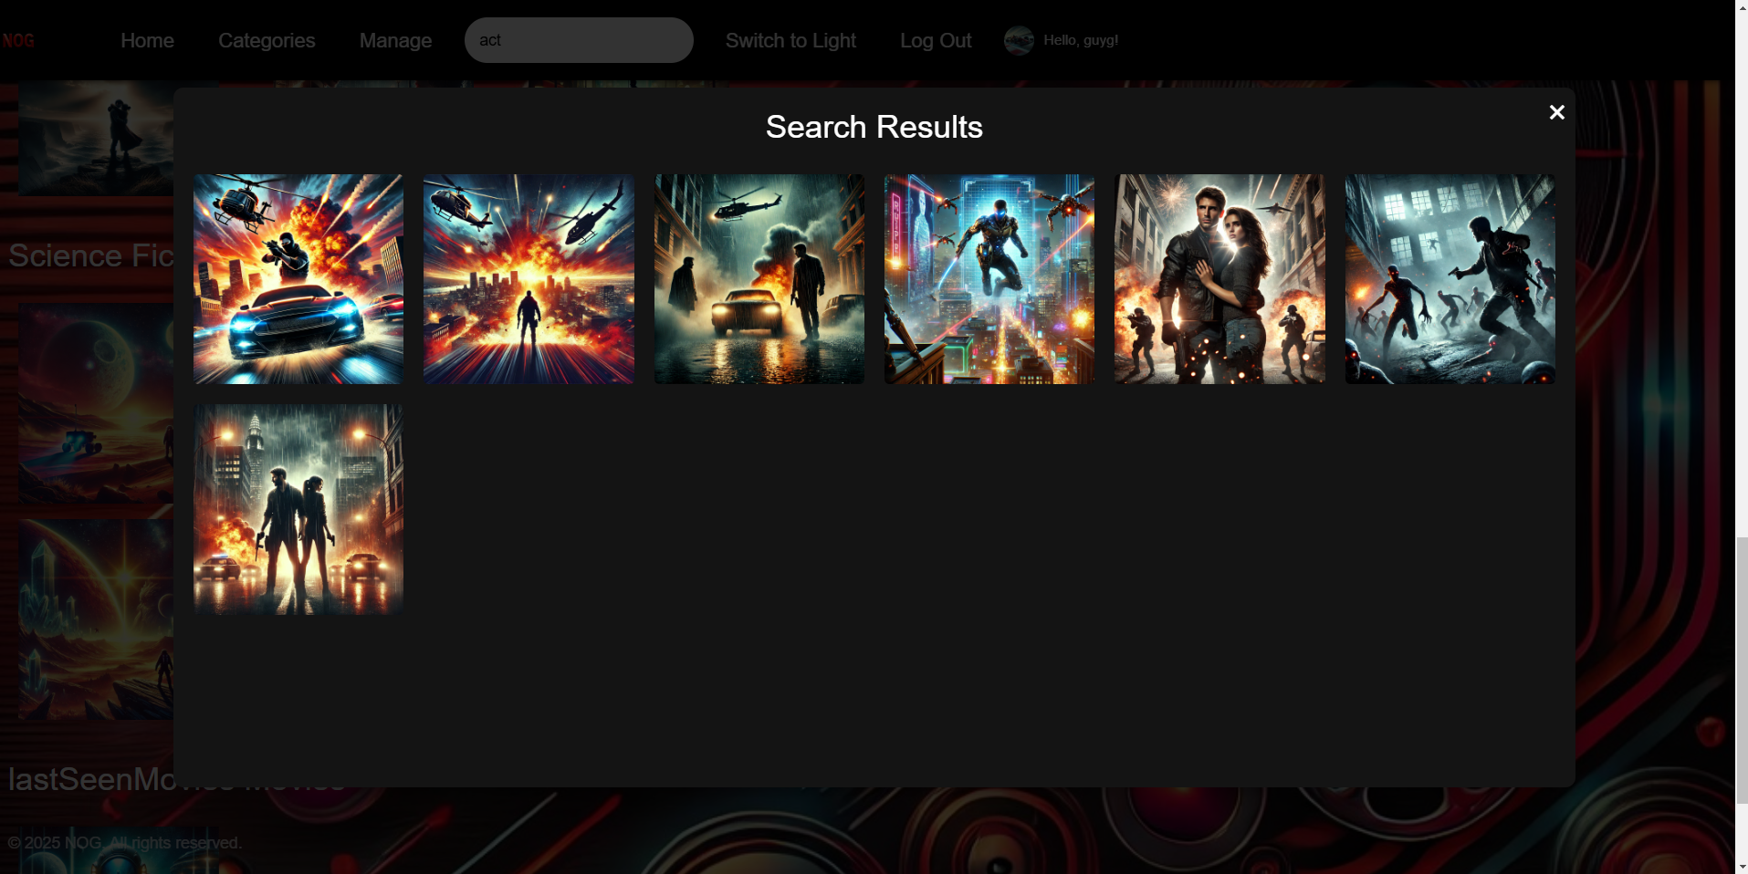

If we want to find all movies that have the substring "ce" in their name, we will notice that all the **Science Fiction** and **Romance** movies meet this criterion. Therefore, we will receive the list of these movies:

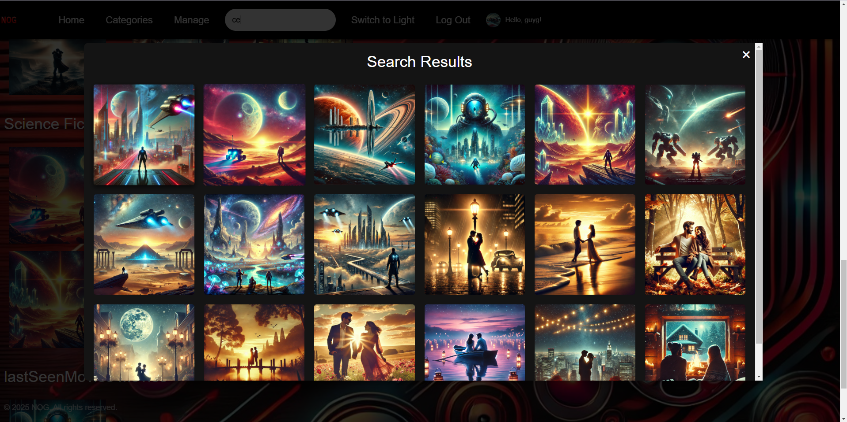

Let's say we want to search for a specific movie, for example, the following movie:

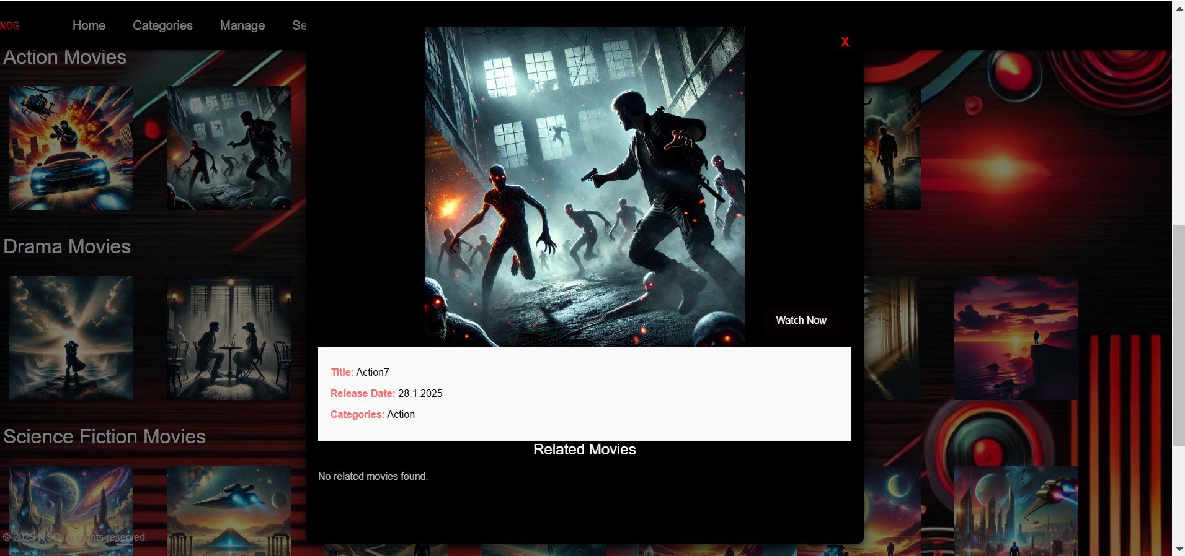

We will type the movie name **Action7** in the search bar, and we will receive exactly that movie in the search results:

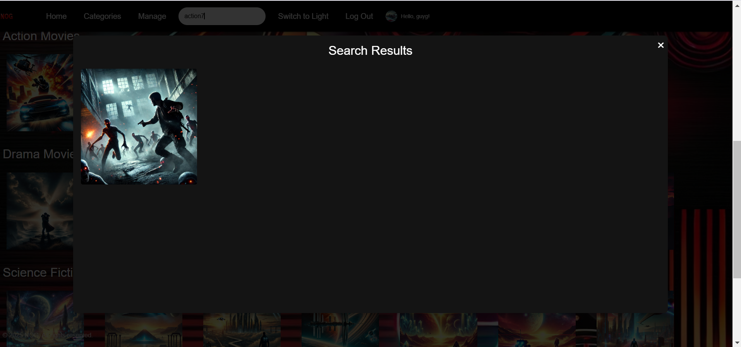

When we click on it, we will see the details of the movie:

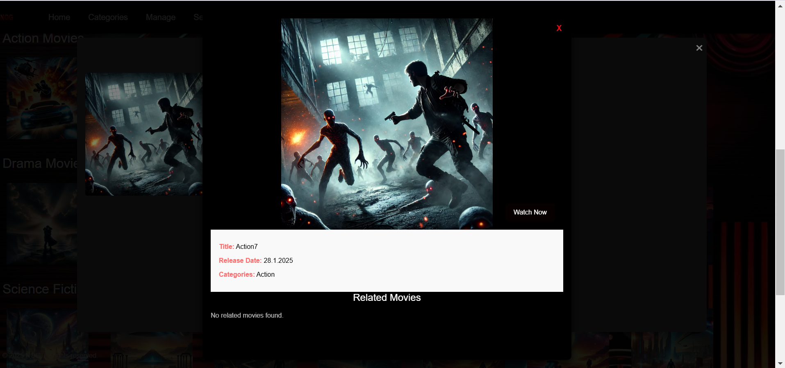

We will notice that there is no movie named **Action8** in the database. Next, we will perform a search for this movie on our website.

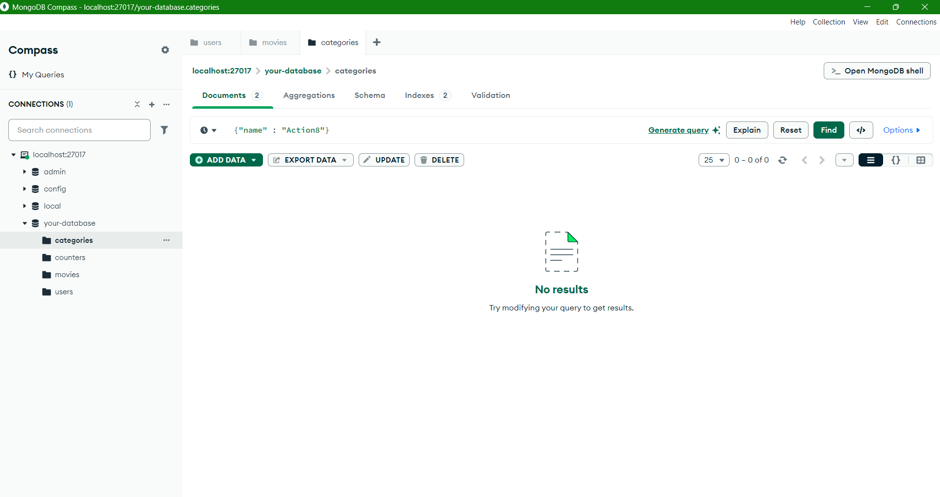

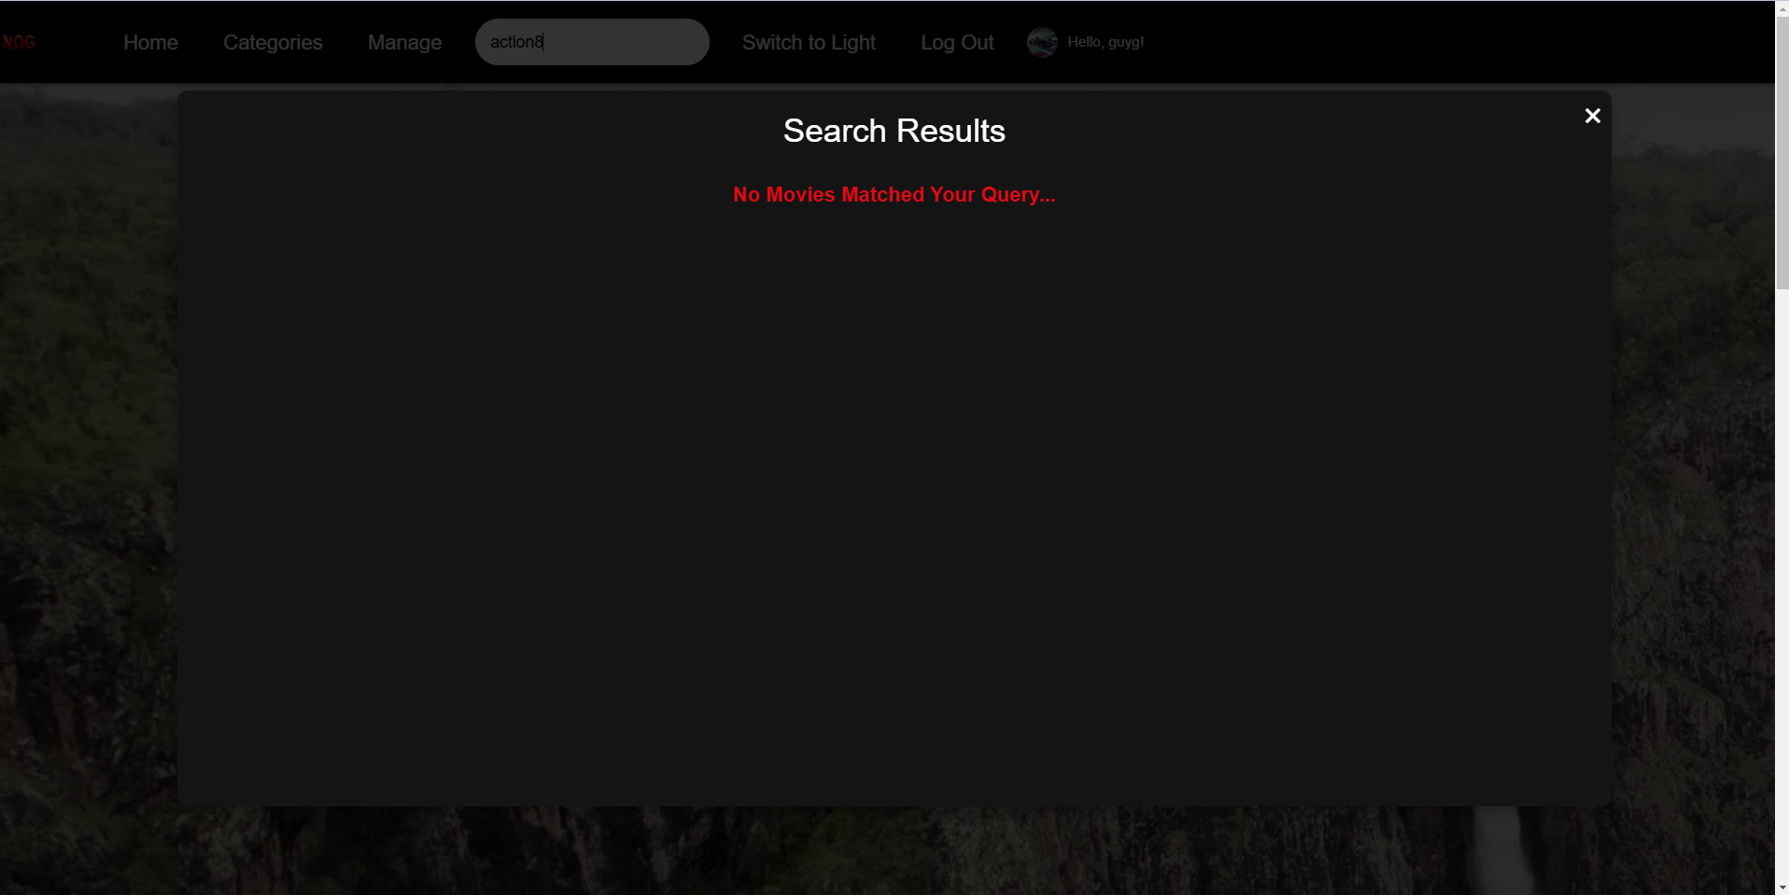

We will notice that, in addition, we can choose between **Light Mode** and **Dark Mode**. We can switch back and forth using the **Switch to Light** button, which changes to **Switch to Dark** when clicked.

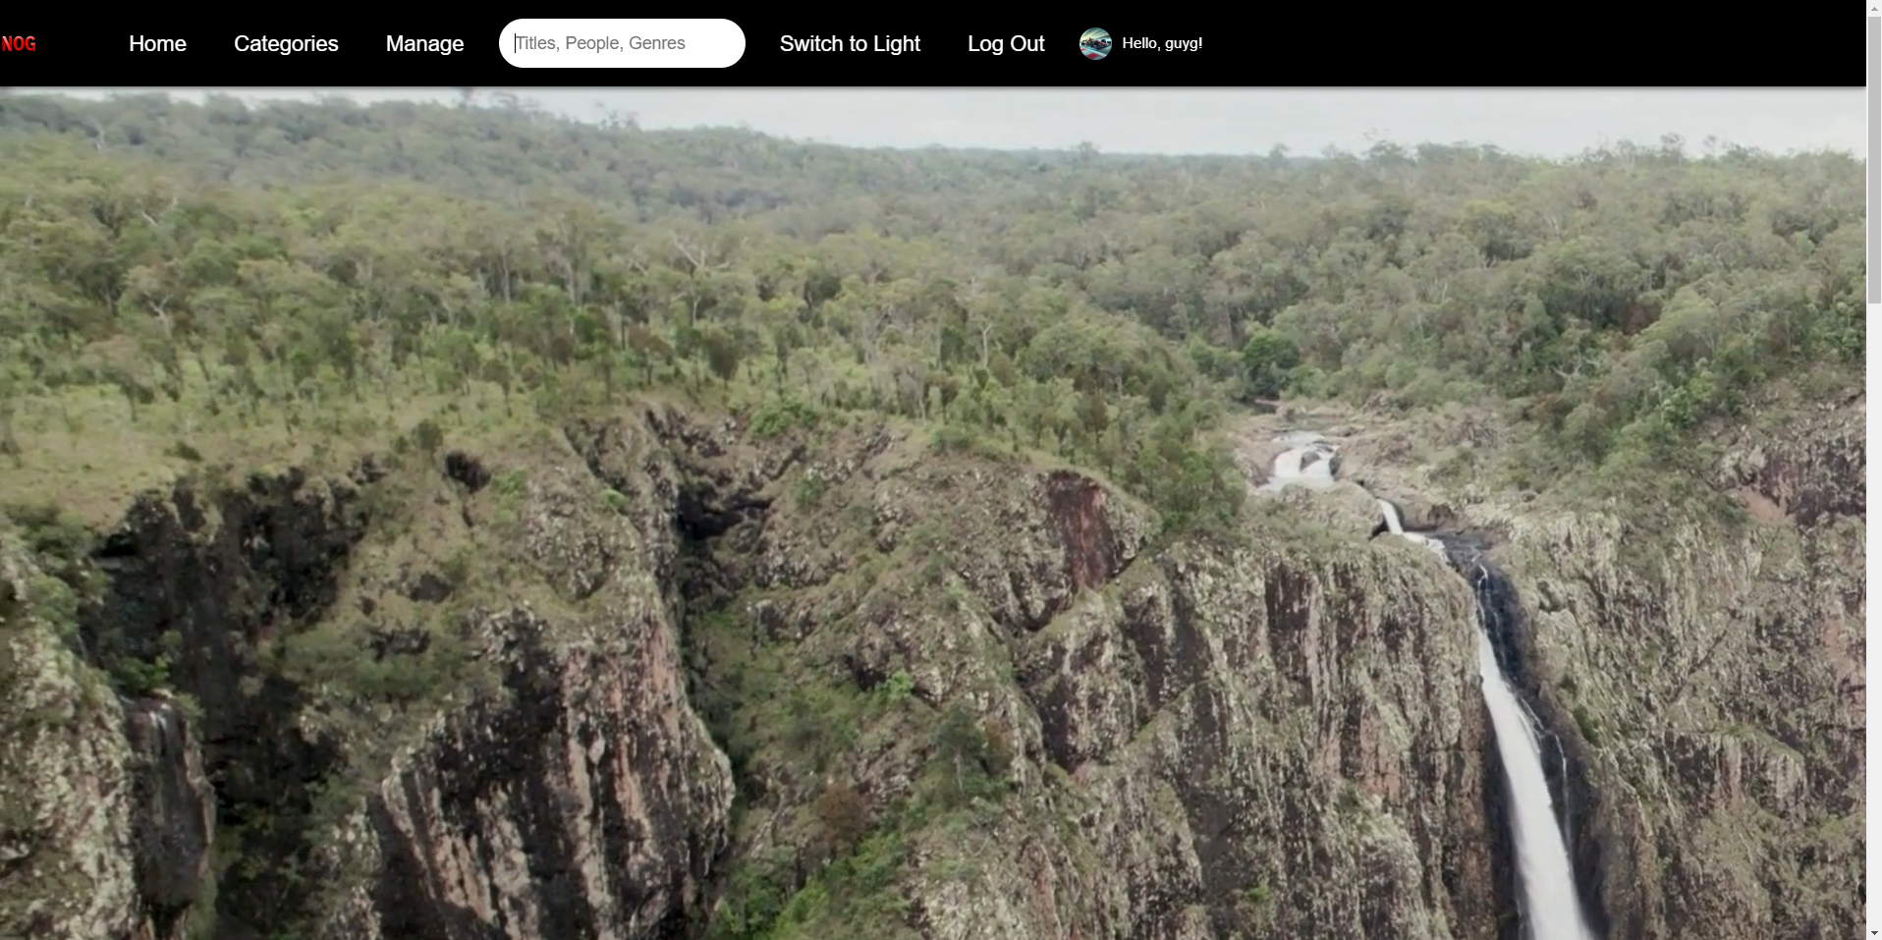

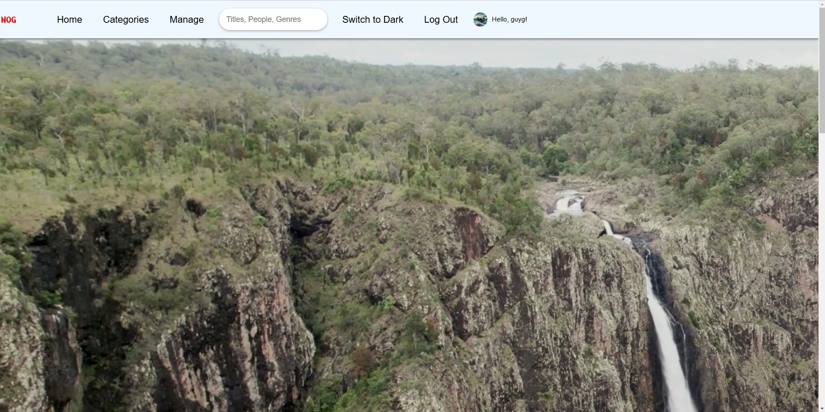

Now, let's demonstrate logging in with a different user. We will perform **LogOut** and return to the homepage.

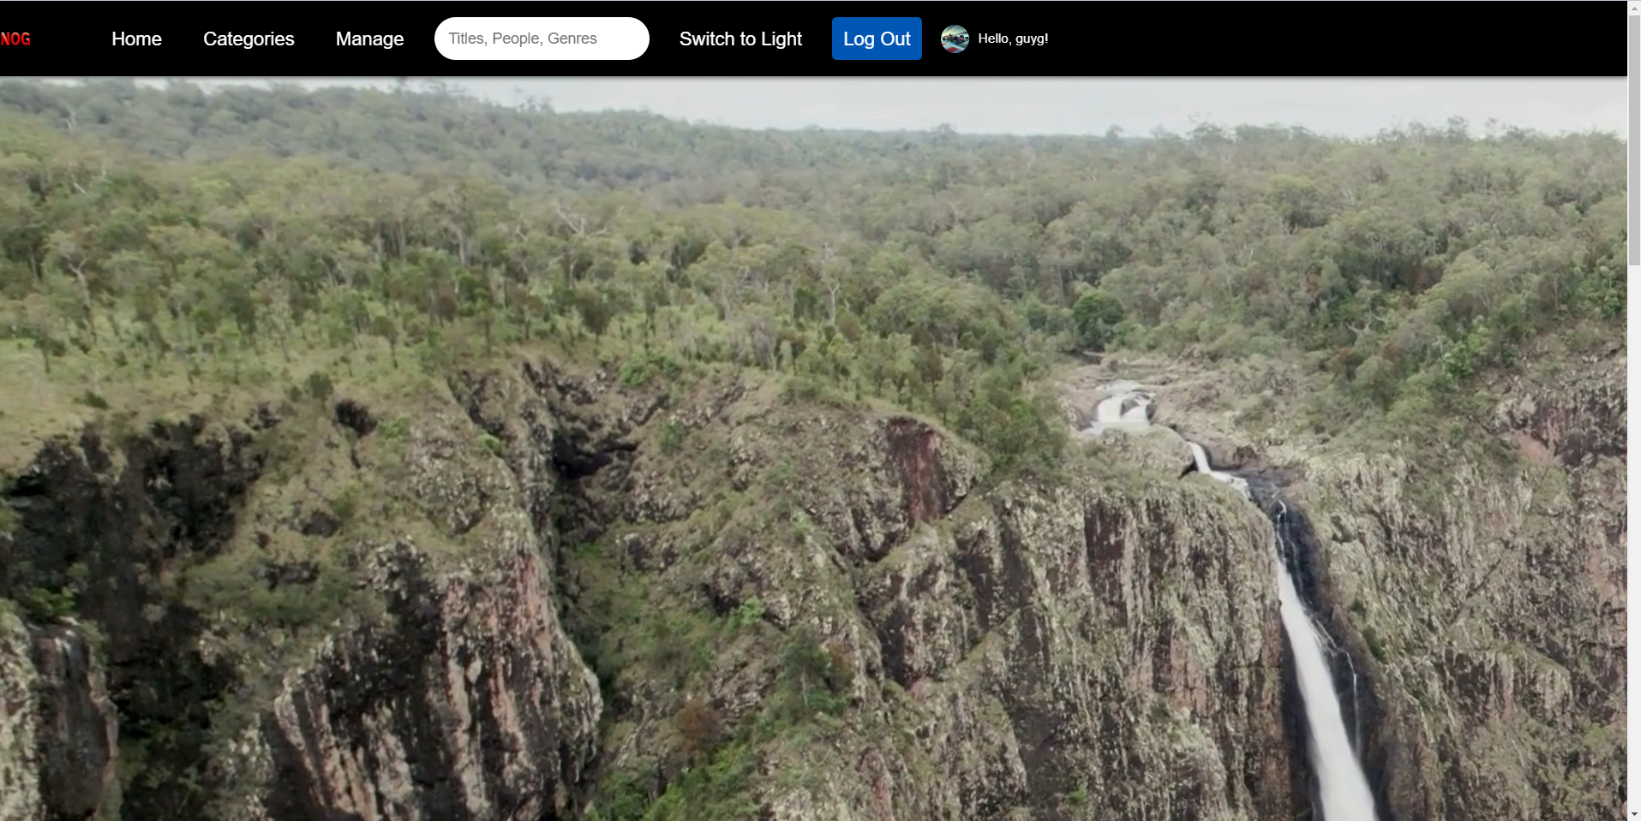



Just like before, we will click on the **Get Started** button and fill in the details for a new user. Afterward, we will log in to the site with the new user credentials.



Now we can see that we've logged in with a new user and a new image, so the management permissions we had before are no longer available.

We want to showcase the recommendation system in action, so we will watch a few movies from our new user, some of which are shared with the previous user:

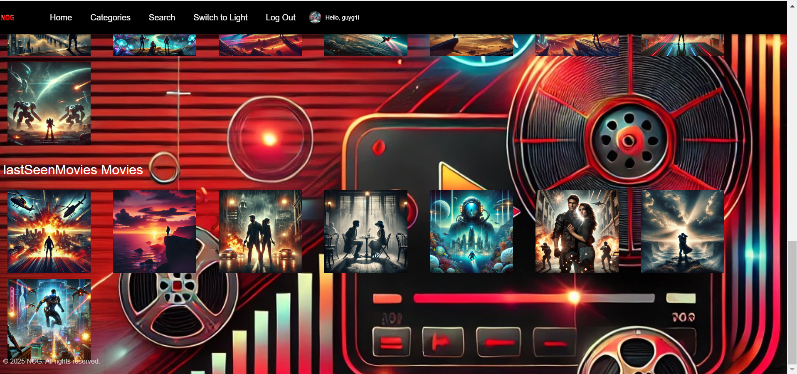

Notice that the movie marked in blue is shared between both users. We will enter it from the second user and check what recommendations are provided for them.

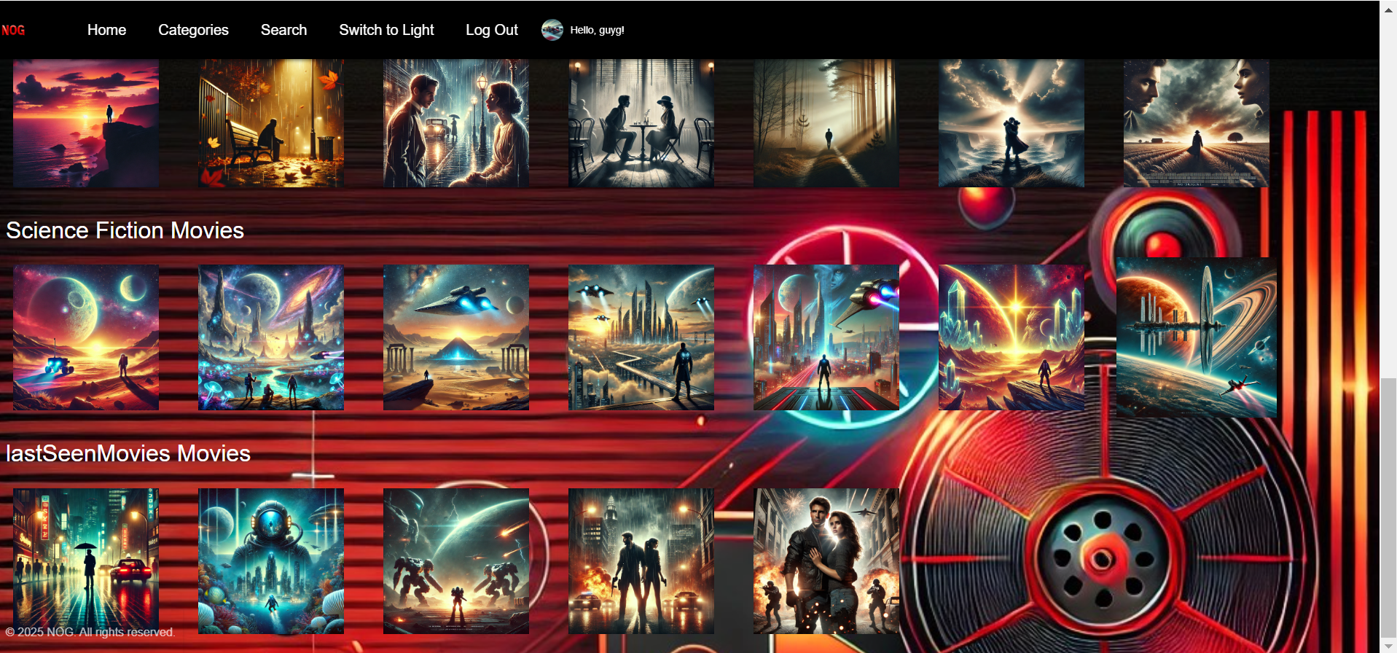

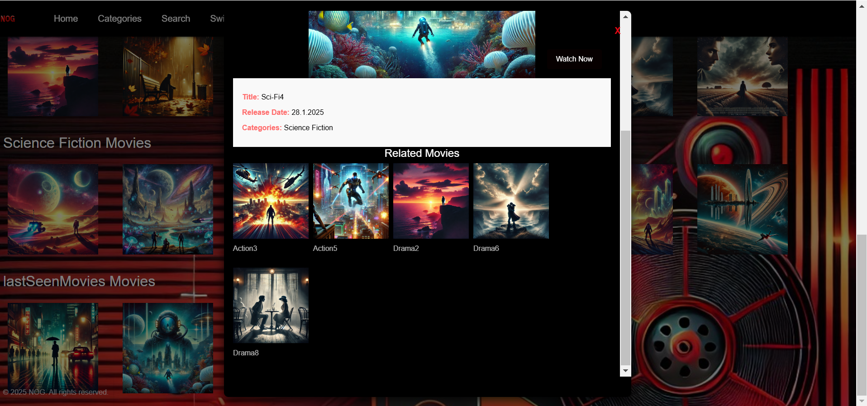

It can be seen that the system was able to recommend movies for the first user based on the shared movie between them and the second user.  
Notice that if you want to watch a recommended movie, you need to look it up with the search bar.

**Now we present the Android App:**

One you open the app you are greeted with the homes screen. 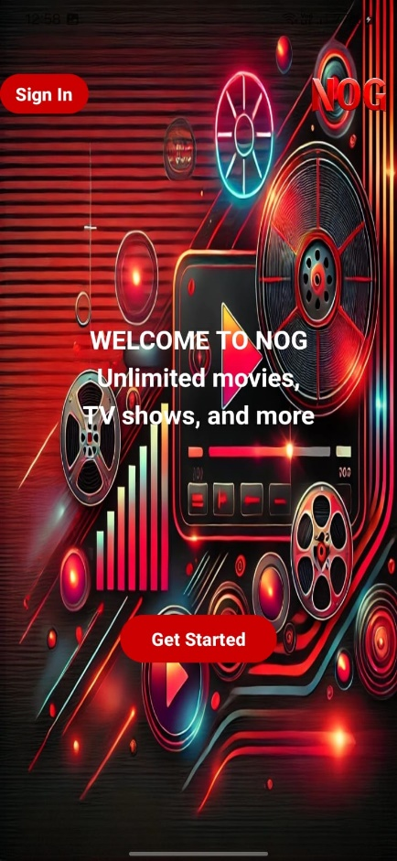

You can click on **Get Started** to create an account, or click on **Sign up** to log in to an existing account:

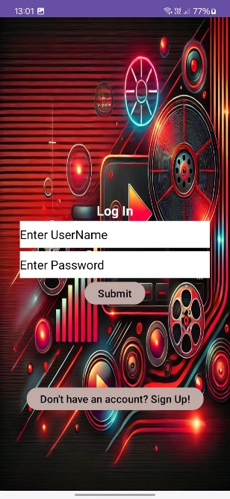 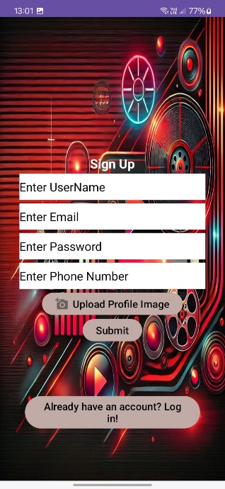

To sign up, you can enter your information, you can upload an image though it is not mandatory.

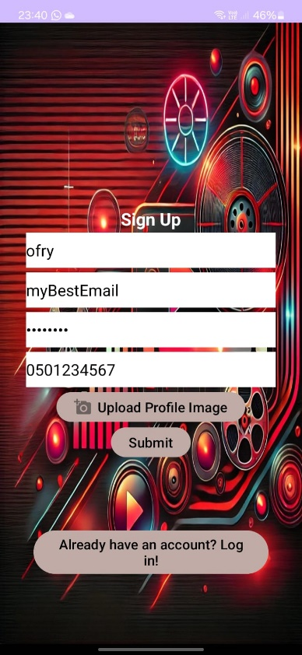 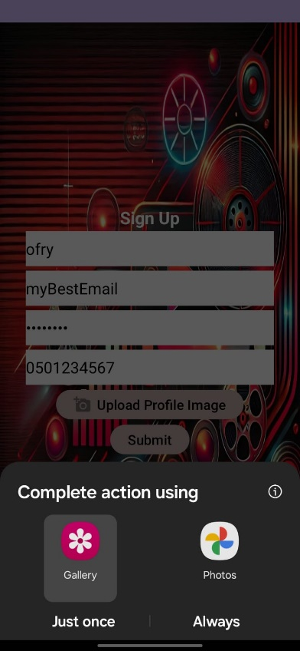 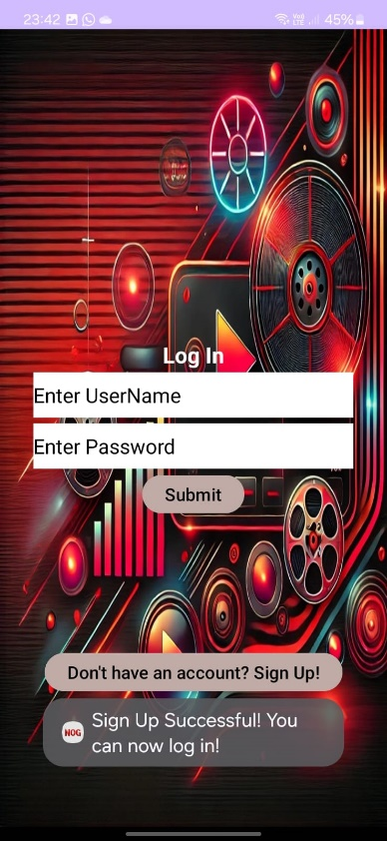

After you secsessfully submit, you are transferd over to the log in screen. There you can enter your username and password and log in.

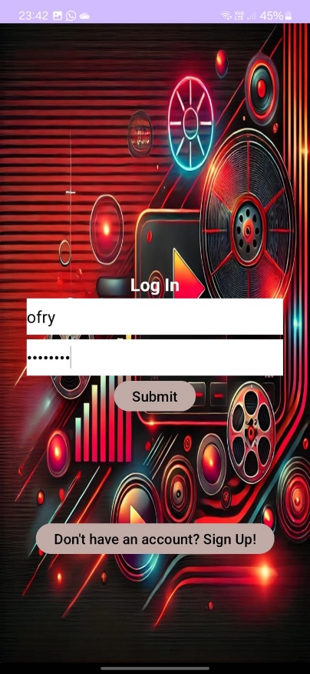 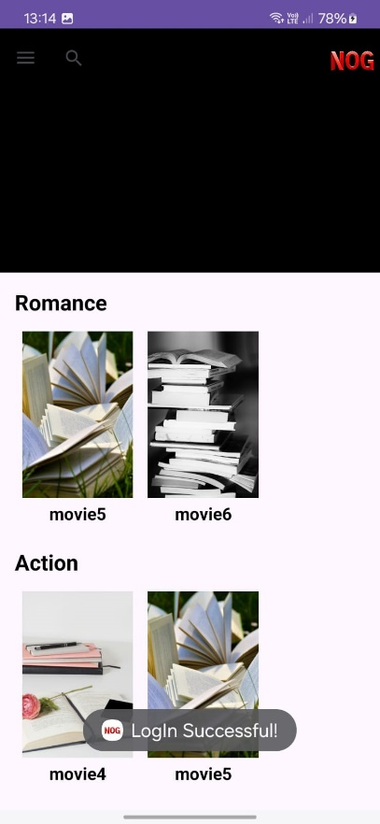

Once you log in you get to the home page where there's a random movie playing at the top of the screen and a list of movies from categories that are popular at the moment.

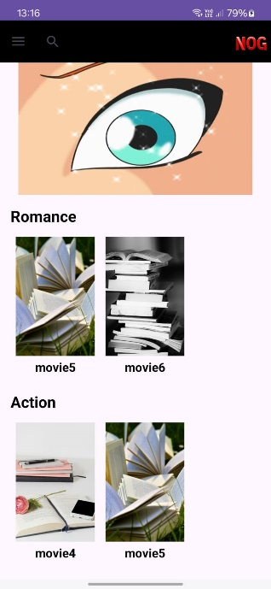



You can access the side panel (circled above) and change the visability mode of the app:

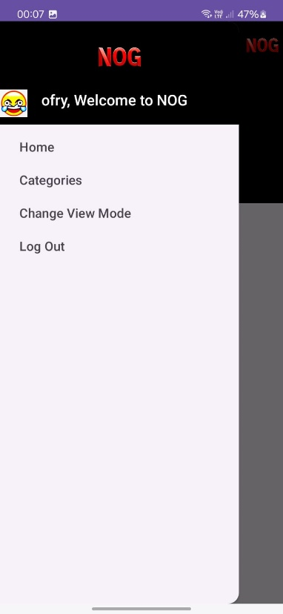 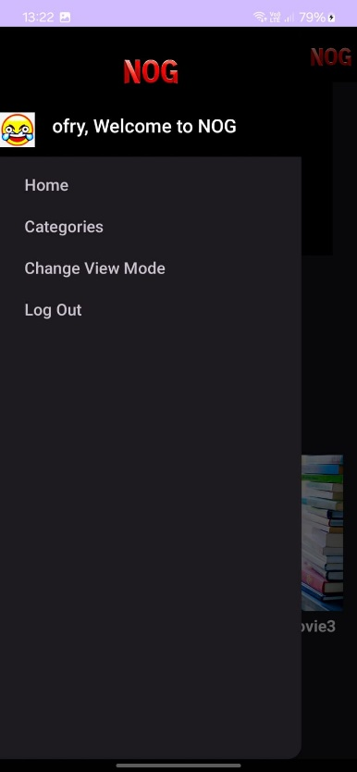



You can log out of your account and go back to the first page of the app.  
you can click on categories where you'll be presented with all the movies from all the categories in the system (see below). The home opthion takes you back to the home page.

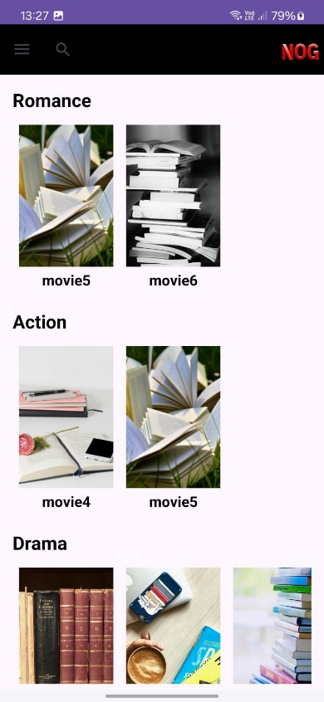

You can click on a movie, see it's detailed and recommended movies similar to the chosen movie:

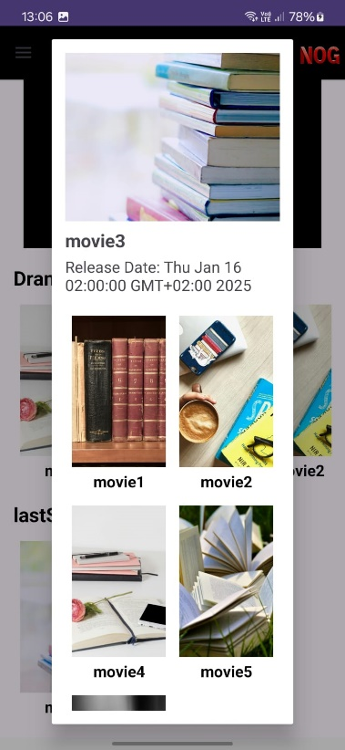

If you want to watch a recommended movie, you can use our search feature and look up it's name:

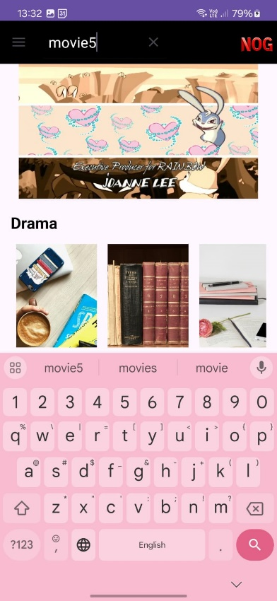 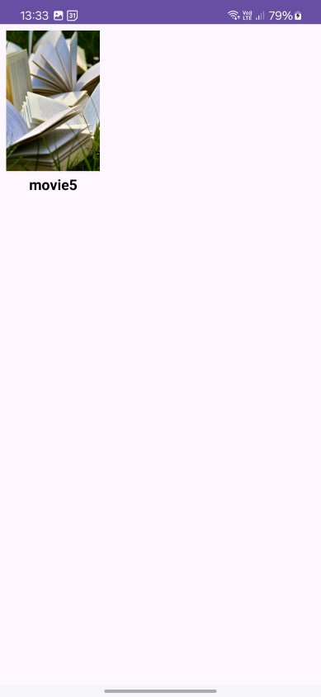

You can click on a movie and watch it:

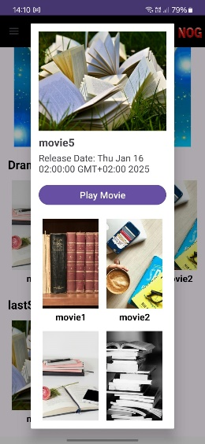 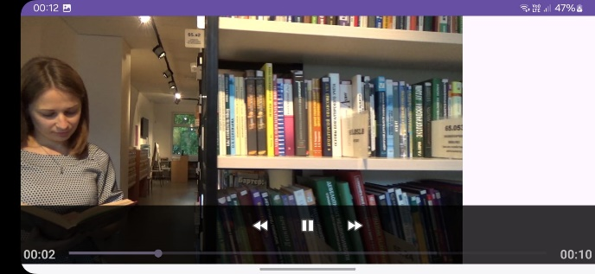

Like you saw in the Web portion, you can promote a user to an admin status if you have access to the mongoDB database. One you do that, an option opens up in the side panel (you might need to log in again for security reasons).

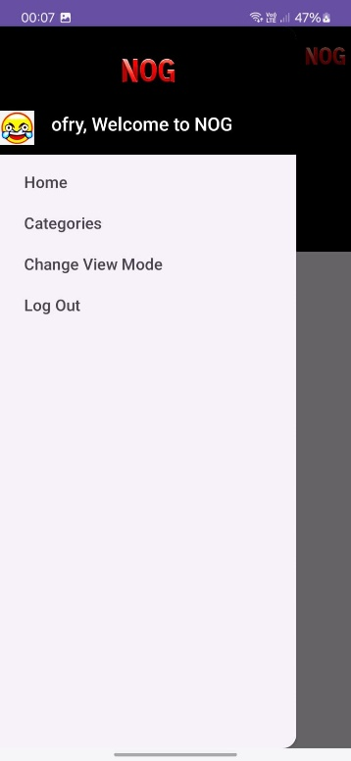 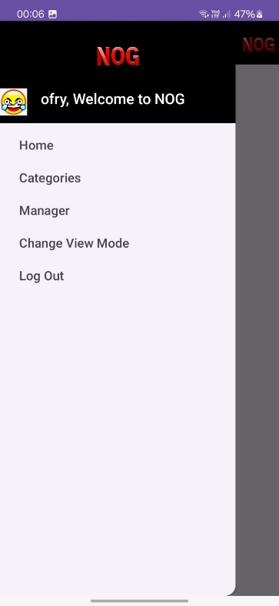

Once you click on the manager option, you can add categories, edit categories and delete them. You can also add movies, edit them and delete them.

In the bottom of the screen you can choose the action you want.

Adding the fantasy category:

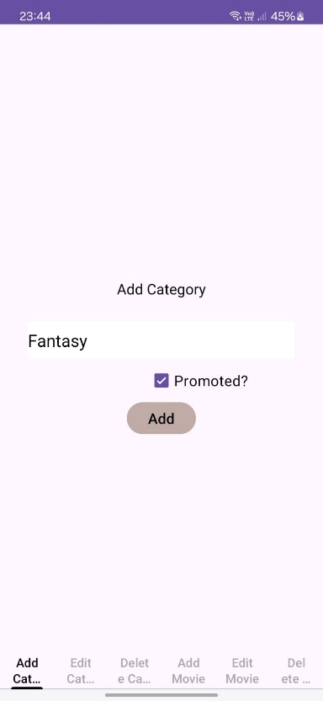 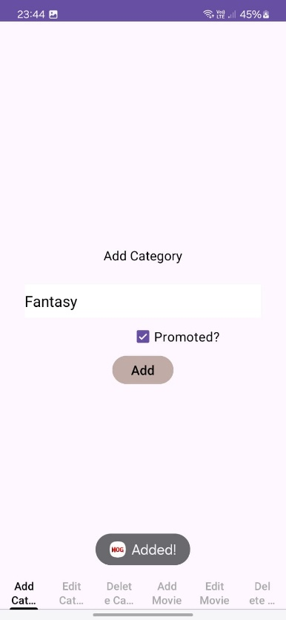

Update (Removing promotion). To find the ID of the category, you go to the mongoDB database -> categories, copie the ObgectId of the category you want (this was filmed after deletion but the catgory should be there once added):

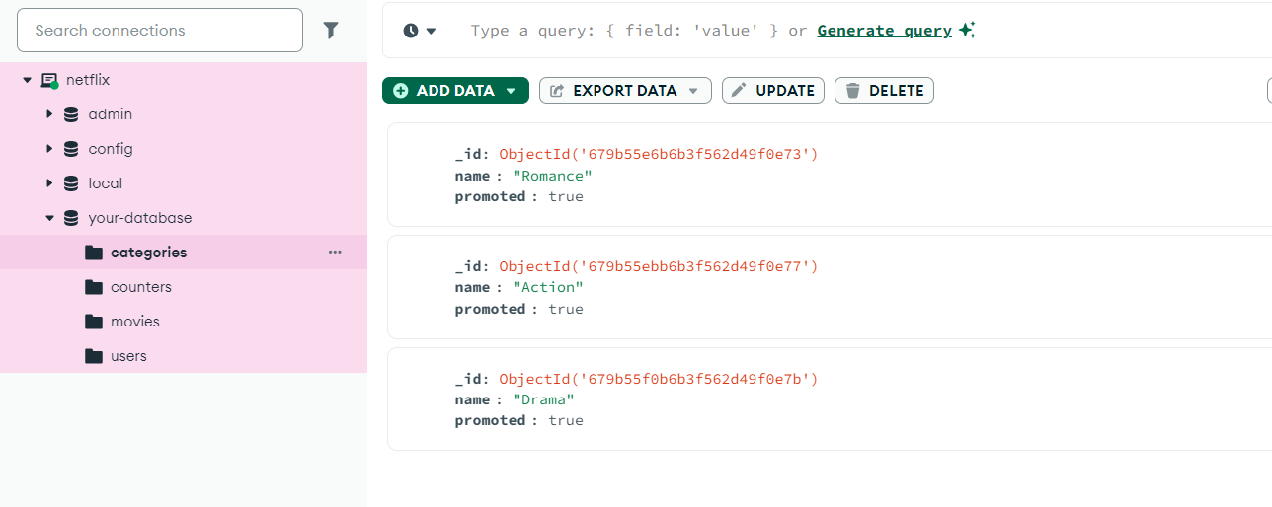

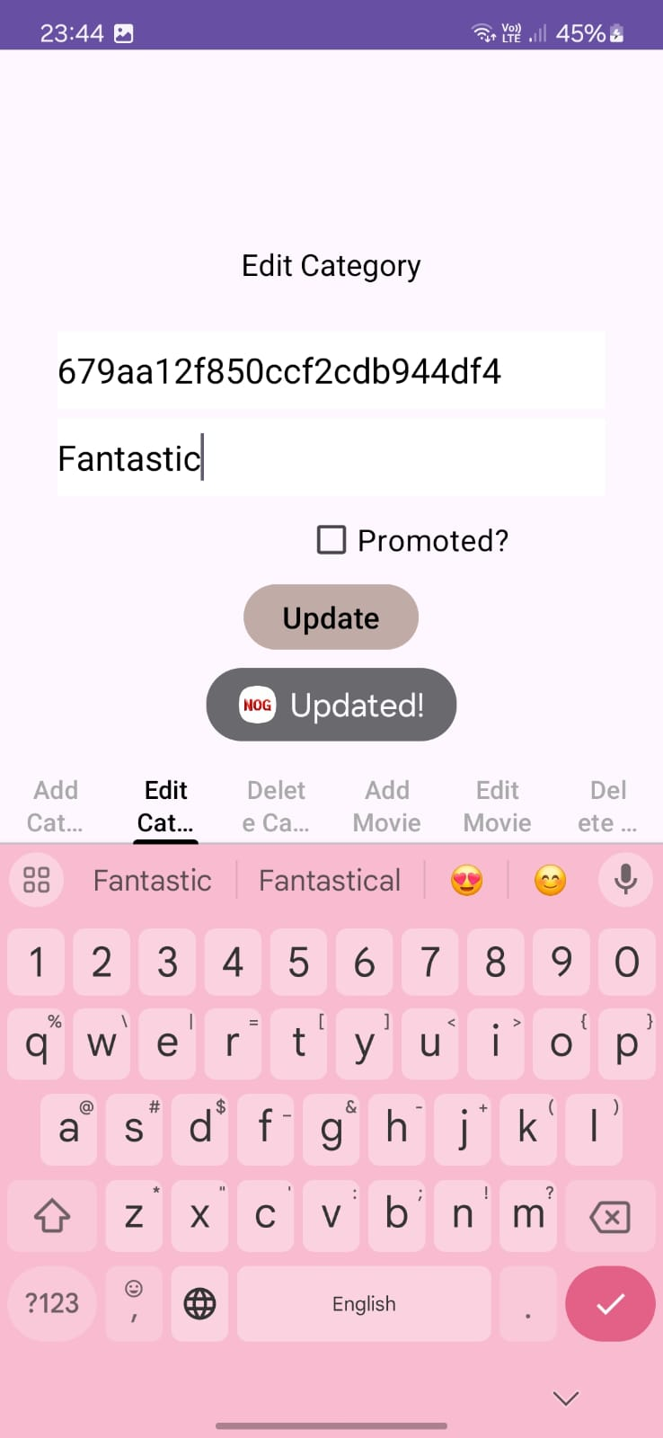

Deletenig the category:

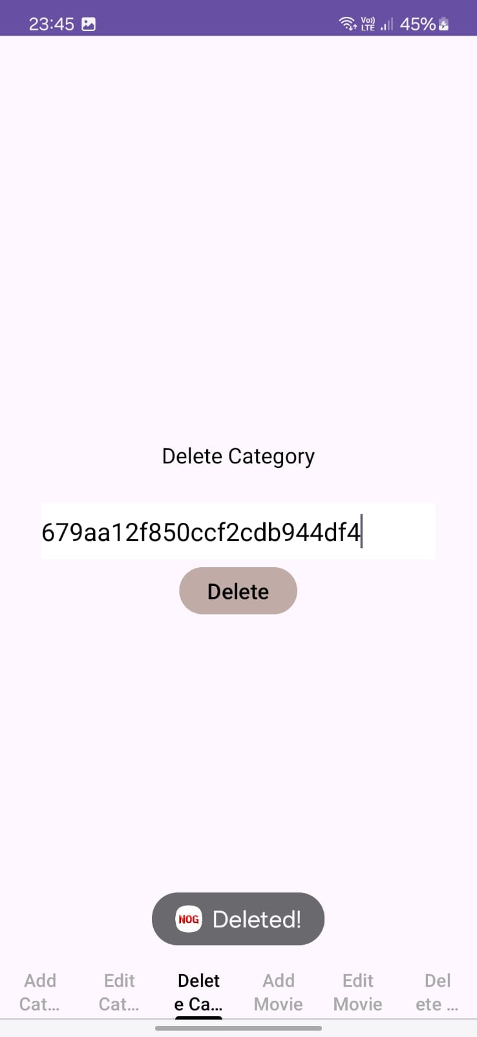

You can do the same with movies:

To add a movie enter the movie detailes. Press "add category" to add the categorie to the movie (you can click the x button to remove mistakes).

Upload a movie video (100MB max) and a photo. When finished click "add".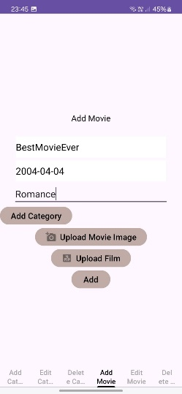 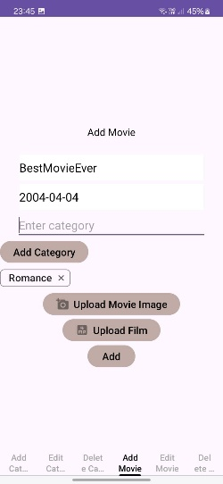 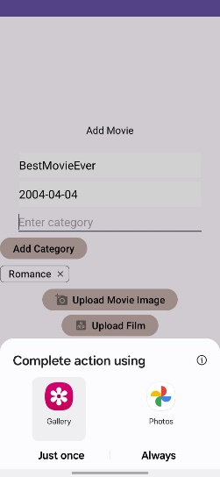 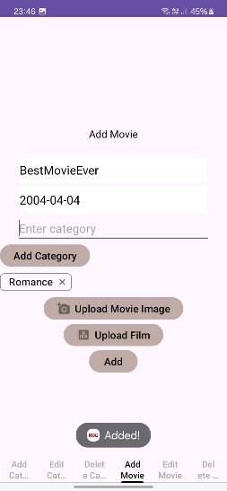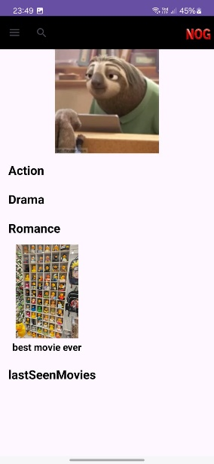

To edit a movie do the same but include the movie Id from the mongoDB.

To delete the movie, simply enter it's id.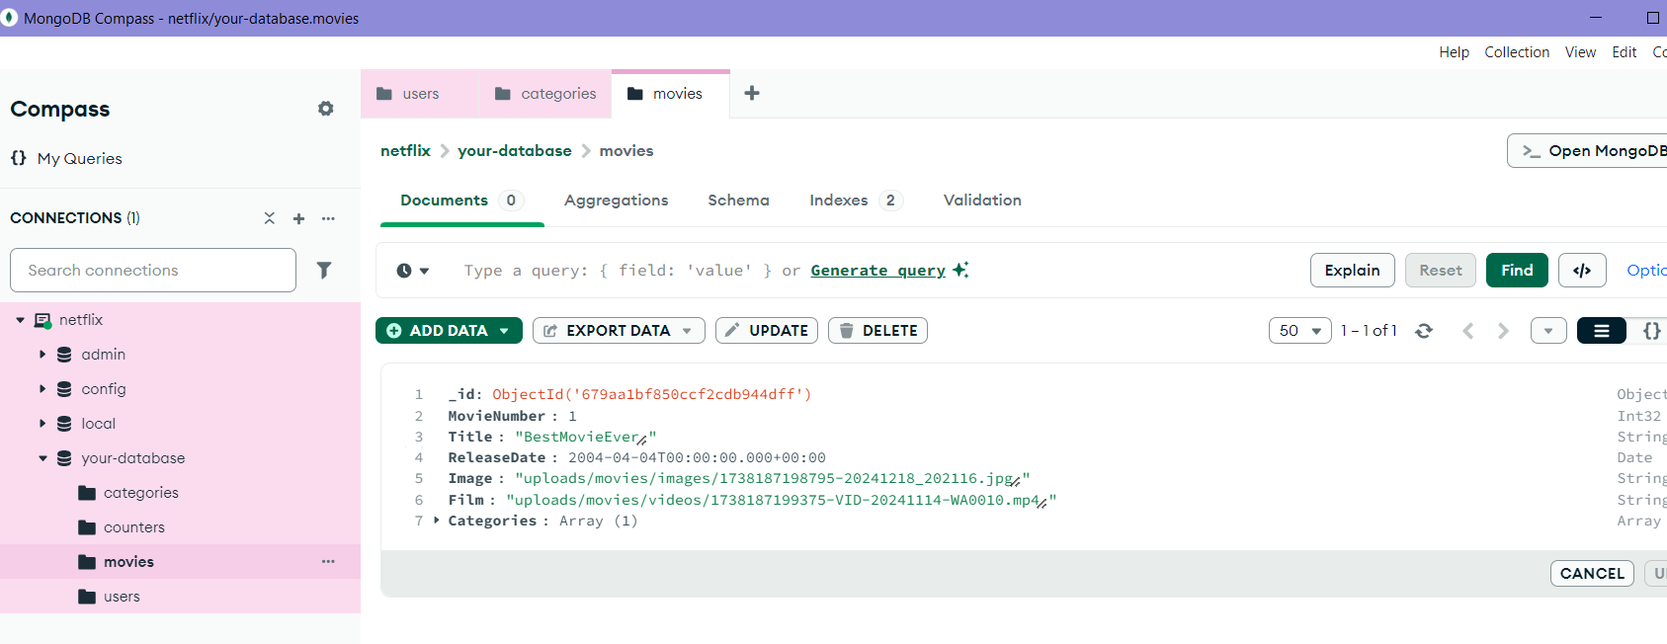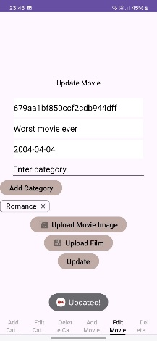 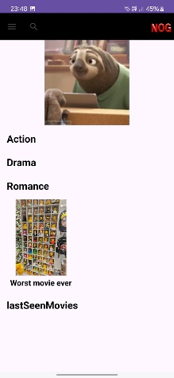 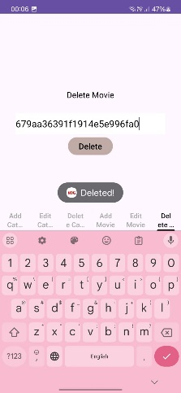 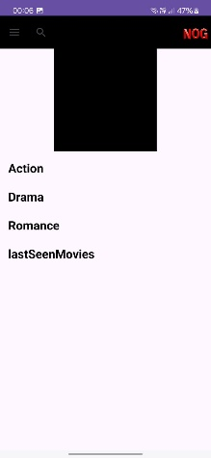



You'll see a different id in the deletion photo because it was taken after I finished taking all the photos.

To go back to the home screen from the Admin area, simply go back to the last page (a featue in every phone).

**That’s it!**hope you enjoy!